The article is published in Ukrainian in the journal. The English text is given in the author's version.

UDC [615.276:547.814.5:611.127]:57.084.1
I.A. Zupanets, S.K. Shebeko, O.S. Ruskin
National University of Pharmacy, Ukraine

Morphological study of antialterative properties of the drug Diclocor at conditions of furasolidone-isadrine myocarditis in rats
Key words: morphological study, alterative lesion, Diclocor, rat’s myocardium

The article presents the results of morphological study by assessment of the antialterative activity of the drug Diclocor (capsules) of PJSC SPC "Borschagivskiy CPP" production, which is an original composition of NSAID diclofenac sodium with flavonoid quercetin. During the study was calculated the values of the mass coefficients of hearts (MCH), analyzed morphostructural changes and conducted semi-quantitative assessment of the degree of necrotic lesion in rat’s myocardium. According to the results of the conducted study it was found that the effectiveness of the drug Diclocor, its ability to normalize values MCH in rats with furasolidone-isadrine lesion of myocardium was 79% and was significantly higher than in the reference objects. The results of semi-quantitative assessment of the degree of necrotic lesion in rat’s myocardium confirm the ability of the study drug to restore the morphostructures of the rat’s myocardium at conditions of alterative lesion. Pronounced antiinflammatory effect of Diclocor on the model of furasolidone-isadrine myocardial lesion in rats allows to substantiate the prospects of application of the investigated object as a cardioprotective remedy.

Current level of applied researches in matters of inflammatory and destructive myocardium lesions far exceeds the limits of a separate cardiovascular system [2,3]. The researchers always point out correlation between cardiovascular complications and basic connective tissue inflammatory markers detection [1,10,12]. For example, summarized results suggest that high cardiovascular risk in patients with rheumatoid arthritis is caused by general immunopathological mechanisms of progression of inflammatory lesions such as cardiomyocytes and chondrocytes [10,13]. Inflammation as a pathological process gradually "transforms" from the phenomenon which consequences lead to dysfunction to the target which requires fine timely treatment. A huge number of antiinflammatory drugs presented at pharmacotherapeutic market of the country, unfortunately, cannot meet the needs of the modern cardiologist due to a number of limitations to the use in cardiovascular patients [5]. In such circumstances, conducting further search of innovative antiinflammatory drugs with cardioprotective properties is considered as completely consistent [4,11,12]. Search within antiinflammatory drugs with cardioprotective properties drew our attention to Diclocor manufactured by PJSC SPC "Borschagivskiy CPP", which represents the original composition of NSAID diclofenac sodium with flavonoid quercetin. Further we represent experimental study data on the characteristics of morphological myocardium structure of rats under the influence of Diclocor under the condition of furazolidon-isadrin lesion.
The aim of this experimental study was the morphological assessment of antialterative activity of the drug Diclocor manufactured by PJSC SPC "Borschagivskiy CPP" compared to reference drugs under conditions of furazolidon-isadrin myocardial injury in rats.
Materials and methods. Morphological study of antialterative activity of the drug Diclocor compared with the reference objects was conducted on furazolidon-isadrin myocarditis (FIM) in rats [7]. Modeling was performed on 50 white rats (nonimbrend) of both sexes weighing from180 to 200 g divided into five groups: "I" (intact animals), "CL" (untreated animals with control lesions), "DC" (animals with FIM under the influence of Diclocor study drug (capsules), manufactured by PJSC SPC «Borschagivskiy CPP» in dose of 17.8 mg/kg), "DS" (animals with FIM under the influence of reference drug with the active ingredient diclofenac sodium (tablets) manufactured by “Novartis Pharma” in dose of 6.8 mg/kg), "Q" (animals with FIM under the influence of the reference drug with the active ingredient quercetin (pellets) manufactured by PJSC SPC «Borschagivskiy CPP» in dose of 11.0 mg/kg). Within 5 days (starting from the first day of the study) each animal from "DC", "DS" and "Q" groups orally received appropriate drug in the form of aqueous suspensions once a day and animal from "I" and "CL" received equivalent volume of 0.9% aqueous solution of sodium chloride. On Day 5 laboratory rats were taken out experiment, morphological study of the myocardium of rats was performed by standard methods. Morphological studies for objectification of the data used semi-quantitative assessment of myocardium necrotic lesion (NL) degree which results were evaluated on a five point scale of necrotic lesions (SNL) that is reflected in Figure 1 [7]. In addition, rats and their heart weighing was carried out with the subsequent calculation of the mass coefficients of hearts (MCH).


Fig. 1. Scale of the semi-quantitative assessment of necrotic lesion degree in rat’s myocardium

Experimental study was conducted according to “European Convention for the Protection of Vertebrate Animals used for experimental and other scientific purposes" requirements. [6] Statistical analysis of the results was performed by methods of variation using Student’s t-test and nonparametric analysis (Mann-Whitney U Test) using computer programs STATISTISA 7.0, StatPlus 2009 and MS Exel 2007 [8,9]; it was represented by comparative table with the results of different groups.
Results and discussion. Macroscopic study of animal hearts with FIM (control lesion) revealed some enlargement of study organ. Visual abnormalities of heart size of animals with FIM under influence of study objects compared with intact rat hearts were not found. So, basically, we observed conventional heart configuration - oblong-conical; muscular walls were thick and, elastic. Cavities of left and right ventricles were narrow and slit; pericardium cavity practically does not contain fluid; epicardium surface is without features; myocardium on a cut was slightly fibrous and had normal structure. Further macroscopic study calculated the value of MCH (Tab. 1). Dynamics of MCH was informative value indicating that group contains rats with control lesion with expressed edema and active inflammation of myocardium. Thus, rats from FIM "CL" group had significant increase of MCH by1.4 times compared with intact rats. At the same time, under the influence of Diclocor this value was significantly reduced by 79% (1.3 times) relative to rats of "CL" group and almost reached the level of intact rats. Under the influence of reference MCH values also tended to normalize by 57% and 14% for "Q" and "DS" group rats, respectively (Tab. 1).
Myocardium sample from "I" group had typical morphological structure: heart muscle fibers had normal thickness, which formed syncytial structure anastomosing among themselves. Cardiomyocytes nuclei of from this group were oblong-oval, normochromal, centrally located; nucleoli were clear contoured and intercalated disk were well visualized. Cross-striation of myofibrils, occupying all sarcoplasma free of nuclei, was weak expressed; tinctorial properties were not impaired. Interfascicular spaces were fixed relatively to small size with moderate cell saturation, and the vessels were full-blooded (Fig. 2a, b).
Unlike "I" group rat’s myocardial morphological structure of "CL" group was characterized by changes caused by available alterative lesion. As it was expected we observed violations of both papillary muscles basis and deeper layers of myocardium. Damages were represented by the initial stages of degeneration of muscle fibers: cross-striation loss and nuclei shrinkage. Some cardiomyocytes were at the stage of necrobiosis: cytoplasm was basophilic; cross-striation intercalated disk were not visualized not, myofibrils were swollen and easing (Fig. 3a, b). Stroma of such sites had reinforced cellular saturation, preferably by undifferentiated cells and lymphocytes (Fig. 3b). Deep necrotic lesions were represented by groups of destroyed fibers and necrotic cell infiltrates (Fig. 3c, d). The level of significant destructive changes was 3.33 points by SNL which is significantly higher than the corresponding values in "DC", "Q" and "DS". So, relevant preparations of myocardium of "Q" group rats had reduction of severity and prevalence of pathological changes in myocardium of rats studied, but overall damage was 1.00 point by SNL. It should be stressed that pathological process involved only individual papillary muscle with cellular infiltration foci. The degree of maturity of cardiomyocytes from "Q" group was significantly higher than for "CL" group (Fig. 4a, b): cardiomyocytes nuclei were monomorphic, myofibrils cross-striation was well observed, connective tissue was perivascular or in the form of thin individual fibers located in the interstitial space (Fig. 4d).
Myocardial preparations of "DS" group rats had moderate changes. Some cellular infiltration foci were localized subendocardially and in the thickness of papillary muscles. The cell clusters were not tight enough and there were numerous fibroblastic elements (Fig. 5a, b). Granulomas surrounding areas as well as rare basophilic swollen fibers did not show myofibrils cross-striation (Fig. 5c). Degenerative changes of nuclei and fiber myocytolisis were not observed. Unaffected parts of myocardium had typical nuclei, and intercalated disk and cross-striation were well defined. With stain by picro-fuchsin (van Gieson's stain) connective tissue elements of cardiomyocytes were defined as moderately expressed fibers (Fig. 5d). Average score by SNL for the group was 1.66.
Against study drug use a significant reduction morphostructural manifestations of alterative myocardial injury was observed in "DC" group. Following morphological picture was observed in myocardial preparations of rats from this group: cell infiltrates that were scattered the myocardium thickness or localized in papillary muscles had isolated small-focal nature (Fig. 6a); maturity degree of cardiomyocytes was significantly higher than in "CL" group. Some muscle fibers were basophilic and myofibrils cross-striation in such areas was shaded (Fig. 6b). Condition of cardiomyocyte cells in the area of tissue lesion was slightly different – enlarged nuclei, slightly rounded shapes, chromatin located paramembranously (Fig. 6B). With stain by picro-fuchsin (van Gieson's stain) connective tissue fibers were detected in small quantities, mainly perivascularly or between bundles of muscle fibers in the form of thin filaments (Fig. 6g). The mean score for the group was 1.00 by SNL. Thus, according to degree of normalization of MCH values in rats under furazolidon-isadrin myocardial injury Diclocor at dose of 17.8 mg/kg had significantly superior activity compared with reference object in "Q" and "DS" groups rate in 1.4 and 5.6 times respectively.

Conclusions.
1. Morphological analysis of destructive changes of studied rats myocardium caused by furazolidon-isadrin lesion found that Diclocor for its ability of morphostructural myocardial recovery and the level of activity is higher than reference objects.
2. Study drug unlocks its potential at early stage of inflammatory myocardial injury actively reducing the intensity of alteration process in damaged tissue (significant efficiency is 79% compared with rats with control lesion). Presence of quercetin in Diclocor composition defines potentiation of its antialterative activity and leveling of cardiotoxic properties of diclofenac sodium.
3. Pronounced antiinflammatory effect of Diclocor on furazolidon-isadrin myocardial injury model in rats is justified allowing prospects of object study as a cardioprotective remedy.

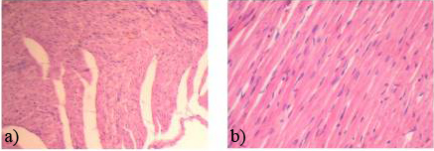
Fig.2. Morphostructure of intact rats myocardium:
a) Papillary muscles of normal structure. Hematoxylin-eosin. ×150;
b) Well pronounced syncytial structure of muscle fibers, elongated nuclei Normochromal. Hematoxylin-eosin. ×250.

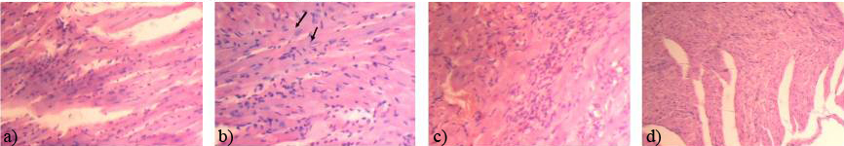
Fig. 3. Morphostructure of rats myocardium with FIM (control lesion):
a) Stained basophilic dyed muscle fibers will swell myofibrils, striation is not defined. Hematoxylin-eosin. ×250;
b) Swollen myofibrils, striation is not defined or are enlightened pyknotic nuclei (arrows). Reinforced saturation interstitium cell. Hematoxylin-eosin×400;
c)The coagulative necrosis of muscle fibers, the cell infiltrates. Hematoxylin-eosin. ×250;
d) Infiltration of cardiac fibers die. Hematoxylin-eosin. ×250.

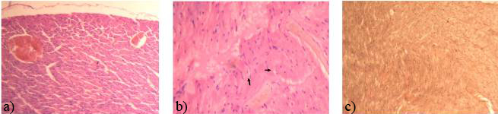
Fig. 4. Morphostructure of rats myocardium with FIM under the influence of quercetin:
а) Advanced and full-blooded veins of various calibers. Hematoxylin-eosin. ×150;
b) Clots in the lumen of blood vessels, swelling of interfascicular spaces, swelling of the fibers, perinuclear hypostases (arrows). Hematoxylin-eosin. ×200;
c) The single thin connective tissue fibers. Pikrofuksin (van Gieson's stain). ×150.
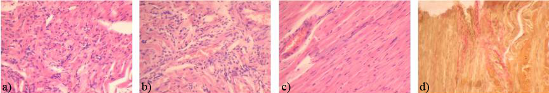
Fig. 5. Morphostructure of rats myocardium with FIM under the influence of diclofenac sodium:
a) Cell infiltration deep in the myocardium. Hematoxylin-eosin. ×250.
b) Perivascular location of medium size cell infiltration. Hematoxylin-eosin. ×250.
c) Plot fibers with altered tinctorial properties and the lack of striations. Hematoxylin-eosin. ×150.
d) Thin connective tissue fibers, appear among cardiomyocytes. Pikrofuksin (van Gieson's stain). ×150.

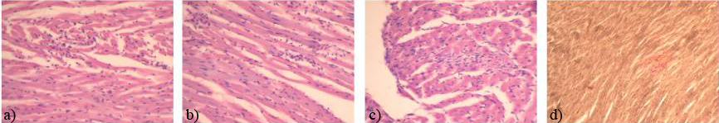
Fig.6. Morphostructure of rats myocardium with FIM under the influence of Diclocor:
a) Small focal infiltrates in the thickness of the myocardium. Hematoxylin-eosin. ×150.
b) Basophil swollen muscle fibers with lost striation. Hematoxylin-eosin. ×200.
c) Anizonucleosis localized in the papillary muscle near the center of the cell. Hematoxylin-eosin. ×200.
d) Thin connective tissue fibers observed among the cardiomyocytes. Pikrofuksin (van Gieson's stain). ×150.
Table 1
Mass coefficients of hearts of intact rats, rats with FIM and rats under the influence of the drug Diclocor/reference objects
Groups | Mass coefficients  of hearts,  %
Intact rats group, n = 10 | 0,37±0,01
FIM of rats group (control lesion), n = 10 | 0,51±0,02*
FIM of rats group under the influence of quercetin, n = 10 | 0,43±0,02**
FIM of rats group under the influence of diclofenac sodium, n = 10 | 0,49±0,02*
FIM of rats group under the influence of Diclocor, n = 10 | 0,40±0,02**/●
Notes:
* - P≤ 0,05 relatively of intact animals;
** - P≤ 0,05 relative to the control lesion group;
● - p≤ 0,05 relative to the rats group under the influence of diclofenac sodium;
n - the number of animals in the group.
Literature
- Непомнящих Л.М., Лушникова Е.Л., Ларионов П.М., Шурыгин М.Г. Регенерация миокарда: Пролиферативный потенциал кардиомиоцитов и индукция кардиомиогенеза при альтеративной и пластической недостаточности сердца // Вестник РАМН. – 2010. – № 5. С. 3-11.
- Meek I.L., Picavet H.S., Vonkeman H.E. et al. Increased cardiovascular risk factors in different rheumatic diseases with the general population // Oxford (United Kingdom). — Р. Rheumatology. – 2012 – 52 (1). – Р. 210-216.
- World Health Statistics 2012. - WHO, 2012. - 176 p. - http://www.who.int/healthinfo/ EN_WHS2012_Full.pdf.
- T. Gusdinar, R. Herowati, R.E. Kartasasmita and I.K. Adnyana, Anti-inflammatory and Antioxidant Activity of Quercetin-3, 3’, 4’-Triacetate. Journal of Pharmacology and Toxicology.2011, 6: 182-188.
- Зайченко Г.В. НПВП: что нового в начале XXI века? // Медична газета «Здоров’я України». – Квітень 2014 р. – № 7 (332). – С. 30-31.
- European convention for the protection of vertebrate animals used for experimental and other scientific purpose: Council of Europe 18.03.1986. - Strasbourg, 1986. - 52 p.
- Доклинические исследования лекарственных средств: Методические рекомендации / Под ред. А.В. Стефанова. – К: Авиценна. – 2002. – 528 с.
- Реброва О.Ю. Статистический анализ медицинских данных. Применение пакета прикладных программ STATISTICA. – 3-е изд. – Москва: МедиаСфера. – 2006. – 312 с.
- Лапач С.Н. Статистические методы в медико-биологических исследованиях с использованием Excel / С.Н. Лапач, А.В. Чубенко, П.Н. Бабич – Киев: Морион – 2000. – 320 с.
- Кардиоваскулярная патология при ревматоидном артрите. Монография/А.А.Дзизинский, Н.А.Храмцова//Иркутск: РИО ГИУВа – 2010. – 150 с.
- Genovese M.C., Rubbert-Roth A., Smolen J.S. et al. Longterm safety and efficacy of tocilizumab in patients with rheumatoid arthritis: a cumulative analysis of up to 4.6 years of exposure // J. Rheumatol. 2013, Jun 1;40(6):768-80.
- A. D. Hingorani and J. P. Casas, “The interleukin-6 receptor as a target for prevention of coronary heart disease: a mendelian randomisation analysis,” The Lancet. 2012, vol. 379, no. 9822, pp. 1214–1224.
- C. P. Chung, J. T. Giles, M. Petri et al., “Prevalence of traditional modifiable cardiovascular risk factors in patients with rheumatoid arthritis: Comparison with control subjects from the multi-ethnic study of atherosclerosis,” Seminars in Arthritis and Rheumatism. 2012, vol. 41, no. 4, pp. 535–544.

