The article is published in Ukrainian in the journal.
The English text is given in the author's version.

UDC [615.276:615.453.42]:57.084.1
EXPERIMENTAL STUDY OF ANTI-INFLAMMATORY PROPERTIES OF THE DRUG "DICLOCOR"
Popov O.S.¹, Zupanets I.A.¹, Shebeko S.K.¹, Shalamay A.S.²
¹National University of Pharmacy, 61057, 27 Pushkinskaya str., Kharkiv, Ukraine
²PJSC SIC “Borshchahivskiy CPP”, Ukraine
Keywords: Diclocor, diclofenac, quercetin, inflammation
Nonsteroidal anti-inflammatory drugs (NSAIDs) are among the most widely used groups of medicines. Despite the undeniable clinical effectiveness, their use is associated with a risk of side effects. This fact directs scientific research to exploring combinations of NSAIDs with other substances in order to identify compositions which can enable reduction of the dosage of the NSAID without losing anti-inflammatory effectiveness. In light of the above, the new combination drug "Diclocor", developed by "Borschagivsky HFZ" (Ukraine), arouses interest. The article presents the results of an experimental study of the anti-inflammatory effect of a combination drug "Diclocor" in comparison with its active monocomponents – diclofenac sodium and quercetin. Alterative stage of inflammation was studied on the model of scarified wounds, exudative stage – on the model of carrageenin oedema, and proliferative stage - on the model of cotton pellet-induced granuloma. All studies were conducted in rats. The experiment results showed the superiority of Diclocor in influencing all three stages of inflammation in comparison with the reference drugs in appropriate doses. Diclocor exhibited the most pronounced effect on the stages of alteration and exudation, and can be described as a promising drug for the treatment of proliferative and destructive inflammatory diseases. Nonsteroidal anti-inflammatory drugs (NSAIDs) are among the most widely used groups of medicines. Despite the undeniable clinical effectiveness, their use is associated with a risk of side effects. This fact directs scientific research to exploring combinations of NSAIDs with other substances in order to identify compositions which can enable reduction of the dosage of the NSAID without losing anti-inflammatory effectiveness. In light of the above, the new combination drug "Diclocor", developed by "Borschagivsky HFZ" (Ukraine), arouses interest. The article presents the results of an experimental study of the anti-inflammatory effect of a combination drug "Diclocor" in comparison with its active monocomponents – diclofenac sodium and quercetin. Alterative stage of inflammation was studied on the model of scarified wounds, exudative stage – on the model of carrageenin oedema, and proliferative stage - on the model of cotton pellet-induced granuloma. All studies were conducted in rats. The experiment results showed the superiority of Diclocor in influencing all three stages of inflammation in comparison with the reference drugs in appropriate doses. Diclocor exhibited the most pronounced effect on the stages of alteration and exudation, and can be described as a promising drug for the treatment of proliferative and destructive inflammatory diseases.

Introduction
Nonsteroidal anti-inflammatory drugs (NSAIDs) are among the most widely used groups of drugs in clinical practice. But despite the undeniable clinical efficacy, their use is associated with a high risk of side effects, which generally occur in 25% of cases, and in 5% are a serious threat to life [1].
Therefore, the search for the drugs combining NSAIDs with other substances that could modify the action of the drug in such a way that the dosage of the NSAID could be reduced while retaining therapeutic efficacy is a perspective scientific realm. One of such promising combination dugs is "Diclocor", containing an NSAID diclofenac sodium and a flavonoid quercetin. The latter is known for its anti-inflammatory effects via blocking leukotriene way of arachidonic acid biotransformation [2, 9, 10-13].
Considering the existence of three different pathogenetic stages of inflammation (alteration, exudation, and proliferation), it appears appropriate to compare the effect of the studied drugs at each of these stages.

Materials and Methods
The object of the study is "Diclocor": the original drug for oral use in capsules (270 mg capsule mass), produced by "Borschagivsky HFZ" (Ukraine). Ingredients (1 capsule):
-quercetin 40 mg
-diclofenac sodium 25 mg.
As reference drugs the following were used: 1. "Quercetin": granules for oral administration containing 4g of quercetin in 100g of granules, manufactured by "Borschagivsky HFZ" (Ukraine). 2. "Voltaren": coated tablets containing 50mg of diclofenac sodium (DS), made by Novartis Pharma (Switzerland).
All drugs were administered to animals in the form of suspensions with the necessary amount of saline solution and stabilizer TVIN-80. Animals in the control pathology group and intact control group received the appropriate volume of saline.
For each phase of the study, 40 nonlinear white rats of both sexes weighing 150-180g were selected. The animals were divided into 4 experimental groups:
Group 1 – control pathology,
Group 2 – animals receiving Diclocor at a dose of 17.8 mg/kg (ED50 for the anti-inflammatory activity),
Group 3 – animals receiving quercetin at a dose of 11.0 mg/kg (the dose equivalent to Diclocor),
Group 4 – animals receiving DS at a dose of 6.8 mg/kg (the dose equivalent to Diclocor).
The study of antialterative properties was conducted on the model of scarified wounds [4], which were made under the hexenal aenesthesia by means of the scarifying device with a diameter of 9 mm and a depth of 5 mm. The area of the wounds was then measured planimetrically in order to determine the healing ability of the drugs. Further, the following parameters were analyzed: healing speed, full healing time, and antialterative activity. The latter was measured by the conventional method, while the healing speed was calculated as follows:
$V=\text{100}×\frac{S_{o}−S_{t}}{S_{o}}$, where
S_{o} - the initial wound area, mm²;
S_{t} - current wound area, mm².

The study of antiexudative properties was performed on the model of aseptic exudative inflammation caused by subplantar injection of 0.1 ml of 1% λ-carrageenin ("Fluka", Switzerland) in the right hind paw. The studied drugs were administered orally once, 1 hour prior to the induction of the pathology.
The volume of the oedema was measured in dynamics 0.5, 1, 2, and 3 hours after carrageenin administration by means of the digital plethysmometer (IITC Life Science, USA).
Anti-inflammatory activity (AIA) was calculated by the formula:
AIA = | ∆Vc –∆Vs | х 100% | , where
AIA = | ∆Vc | х 100% | , where
AIA – antiinflammatory activity (%);
∆Vc – average volume of the oedema in control pathology group;
∆Vs – average volume of the oedema in the studied group.
The study of antiproliferative properties was performed on the model of cotton pellet-induced granuloma [6]. An area of skin on the back of the rats, which were under light ether narcosis, was depilated, and a 1.5 cm longitudinal section of the skin and subcutaneous tissue was then aseptically performed, where a sterile cotton pellet, weighing 20 mg, was placed. On day 8 of the experiment, the granulomas were isolated from the animals and dried to a constant weight at 60°C. The mass of fibrous tissue was determined by the difference between the mass of the dried granuloma and the implanted cotton pellet. Results were expressed in mg and % in comparison with the control group.
The received results were analyzed by means of variation statistics using Student’s t-test and nonparametric methods (Mann – Whitney U-test). Utilized computer software included STATISTICA 7.0, StatPlus 2009 and MS Excel 2007 [3-5].
All animal studies were performed in accordance with Directive 2010/63/EU on the protection of animals used for scientific purposesp [4,7].
Results and Discussion
Alteration is the initial stage of inflammation, characterized by tissue damage and including a variety of cellular and extracellular changes at the site of damage. This phase can be considered as a dialectical unity of changes caused by the aggressive trigger and the local protective reactions like microcirculation changes, tissue necrosis, and the reaction of the integral regulatory systems of the whole organism [8].
The results of the study have shown that Diclocor reveals a better healing effect in comparison with the reference drugs – quercetin and DS. This pattern is illustrated by the calculated wound areas, healing speed, and antialterative activity. These parameters were studied at days 3, 5, 7, 9, 11, 13, 15, 17, 19, and 21.
The process of scarring varied in different experimental groups. Complete epithelization in the control group occurred on day 21, in Diclocor group – on day 15, in quercetin group –on day 19, and in DS group – on day 21 of the experiment (picture 1).Thus, Diclocor exceeded reference drugs and control pathology group at all periods. The results of the study indicate that, when administered together, diclofenac and quercetin exhibit potentiated antialterative effect.
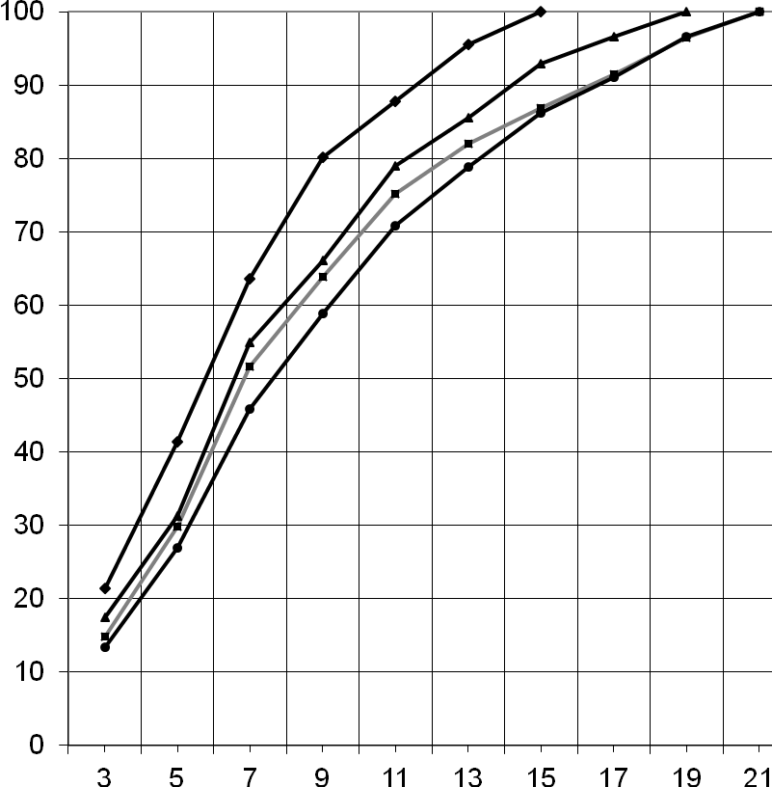
Healing speed, %
Day
♦ – Diclocor 17.8 mg/kg
 – quercetin 11.0 mg/kg
 – DS 6.8 mg/kg
 – control pathology
Picture 1. The influence of Diclocor and reference drugs on healing of scarified wounds.

The results of the study of antiexudative properties suggest that Diclocor has a strong inhibitory effect on cyclooxygenase path of conversion of arachidonic acid and, thus, reduces the intensity of prostoglandin synthesis in inflammation, significantly surpassing DS after 1 and 3 hours of the experiment, and quercetin - at all stages. The activity of Diclocor on this model is mainly due to the presence of diclofenac in its composition and the additive effect of quercetin.
Quercetin was significantly inferior to Diclocor and DS on this model of inflammation. In our opinion, this phenomenon is explained by the absence of COX-dependent anti-inflammatory action in its pharmacodynamics, as the main target of this drug is the leukotriene pathway of arachidonic acid biotransformation. The results of the study are presented in table 1.
Table1
Antiexudative activity of Diclocor and reference drugs (n=40)
Group | Dose, mg/kg | 0,5 hour |  | 1 hour |  | 2 hours |  | 3 hours
Group | Dose, mg/kg | Paw volume growth, cm³ | Activity,  % | Paw volume growth, cm³ | Activity,  % | Paw volume growth, cm³ | Activity,  % | Paw volume growth, cm³ | Activity,  %
CP | – | 0,83±0,06 | – | 1,34±0,01 | – | 2,65±0,14 | – | 3,68±0,21 | –
D | 17,8 | 0,67±0,04  */** | 19,3±1,2  ** | 0,94±0,04  */** | 29,8±1,4  **/• | 1,58±0,08  */** | 40,4±2,0  ** | 1,41±0,06  */**/• | 61,7±2,7  **/•
Q | 11,0 | 0,80±0,04 | 3,6±0,2 | 1,20±0,05 * | 10,5±0,5 | 2,10±0,12 * | 20,8±1,2 | 3,10±0,07 * | 15,8±0,4
V | 6,8 | 0,69±0,04 | 16,9±0,9 | 1,00±0,05 * | 25,4±1,2 | 1,63±0,04 * | 38,5±0,9 | 1,76±0,06 * | 52,2±1,7

* – p <0.05 compared to the control pathology CP – control pathology
** – p <0.05 compared to animals treated with quercetin D – Diclocor
• – p <0.05 compared to animals that received DS Q – quercetin
V – DS
Proliferation is the final stage of inflammation and is accompanied by the development of young connective tissue – granulations, characterized by special architectonics of the vessels which form capillary loops [8].
The results of the current study showed that the investigated objects have moderate antiproliferative activity, which was confirmed by reduction of granulation tissue formation compared to the rats of the control pathology group (table 2).
Table 2
Antiproliferative activity of Diclocor and reference drugs (n=40)
Group | Dose, mg/kg | Quantity of granulation tissue, mg | Activity,  %
Control pathology | – | 45,2±1,7 | –
Diclocor | 17,8 | 34,3±1,3 */● | 24,12±0,88 **/●
Quercetin | 11,0 | 37,0±1,4 * | 18,14±0,66
DS | 6,8 | 39,1±1,4 * | 13,50±0,49
*– p <0.05 compared to the control pathology
**– p <0.05 compared to animals treated with quercetin
•– p <0.05 compared to animals that received DS

Diclocor has moderate antiproliferative properties having shown antiproliferative activity 1.3 times higher than quercetin and 1.8 times higher than DS. The difference between these figures was reliable.

Conclusion
Thus, comparing the effect of Diclocor on the three stages of the inflammatory process, it can be stated that the highest impact was made on alteration and exudation stages. Moderate effect was also observed in proliferation stage. This pattern is consistent with the correlation between the antialterative and the antiproliferative activity of NSAIDs, which can be explained by their ability to inhibit biosynthesis of collagen. This property is advantageous for treatment of rheumatoid arthritis and negative for treatment of osteoarthrosis and traumatic arthritis.
In our case, quercetin modifies anti-inflammatory capability of diclofenac sodium making such combination a promising one for treating destructive and proliferative diseases. Therefore, further studies of Diclocor are needed, especially in the course of alterative and proliferative processes.

Literature
. Коваленко В.М., Борткевич О.П., Проценко Г.О. Нестероидные противовоспалительные препараты: роль и место в современной ревматологической практике на основании доказательной медицины // Украинский ревматологический журнал.– 2006.– Т. 23, № 1.– С. 17-29.
2. Ковалев В.Б., Ковган В.В., Колчина Е.Ю. Механизмы лечебного действия биофлавоноида кверцетина (обзор литературы) // Український медичний альманах.– 1999.– Т. 2, № 4.– С. 176-182.
3. Лапач С.Н. Статистические методы в медико-биологических исследованиях с использованием Excel // С. Н. Лапач, А. В. Чубенко, П. Н. Бабич.– К.: Морион, 2000.– 320 с.

4. Миронов А.Н., Бунатян Н.Д. и др. Руководство по проведению доклинических исследований лекарственных средств. Часть первая.– М.: Гриф и К, 2012.– 944 с.
5. Прозоровский В.Б. Практическое пособие по ускоренному определению средних эффективных доз и концентрации биологически активных веществ // Прозоровский. В.Б.– СПб, 1992. – 42 с.
6. Стефанова А.В. Доклинические исследования лекарственных средств: Методические рекомендации // Под ред. Стефанова. А.В.– К: Авиценна, 2002.– 528 с.
7. Стефанов О., Бухтіарова Т., Коваленко В. та ін. Настанова СТ-Н МОЗУ 42-6.0:2008. Лікарські засоби. Належна лабораторна практика (видання офіційне) // К.: Моріон, 2009.– С. 37-68.
8. Струков А.И., Серов В.В. Патологическая Анатомия. 5-е издание.— 2010.— 848 с.
9. Chi-Yu Y., Su-Lan H., Kuo-Ching W. et al. Bioavailability and Metabolitic Pharmacokinetics of Rutin and Quercetin in Rats // Journal of Food and Drug Analysis.– 2005.– Vol. 13.– P. 244-250.
10. Das N. et al. Quercetin alleviates inflammation after short-term treatment in high-fat-fed mice // Food & Function.– 2013.– Vol. 4(6). – P. 889–898. Available at: http://dx.doi.org/10.1039/C3FO30241E.
11. Gardi C. et al. Quercetin reduced inflammation and increased antioxidant defense in rat adjuvant arthritis // Archives of biochemistry and biophysics. – 2015. – Vol. 583. – P. 150–157.
12. Marcolin E. et al. Quercetin Treatment Ameliorates Inflammation and Fibrosis in Mice with Nonalcoholic Steatohepatitis. The Journal of Nutrition.– 2012.– Vol. 142(10) .– P.1821–1828.
13. Rogerio A.P. Anti-inflammatory activity of quercetin and isoquercitrin in experimental murine allergic asthma // Inflamm. Res.– 2007.– Vol. 56.– P. 402-408.

Popov O.S. – assistant of the Department of clinical pharmacology and clinical pharmacy, NUPh
Zupanets I.A. – Head of the Department of clinical pharmacology and clinical pharmacy, NUPh, PhD, professor
Shebeko S.K. – docent of the Department of clinical pharmacology and clinical pharmacy, NUPh, PhD
Shalamay A.S. – Director of Science in Borshchagivskiy HFZ, PhD

E-mail: clinpharm@nuph.edu.ua

