The article is published in Ukrainian in the journal.
The English text is given in the author's version.

UDC 615.035.1:615.252
EXPERT ASSESSMENT OF DRUGS APPOINTMENT FOR PHARMACOTHERAPY OF THYROID DISEASE
I. M. Klishch, Yu. S. Zabihaylo
Ternopil State Medical University
Key words: pharmacotherapy, thyroid disease, expert assessment.
It is known that the main factor that forms a demand for drugs for treatment of thyroid diseases is doctor. However this issue in the modern scientific literature is not properly highlighted. The aim of our study was to obtain reliable information about the range of drugs used for pharmacotherapy of thyroid diseases in Ternopil region hospitals. As experts were 35 endocrinologists from different medical institutions. The largest share were experts with practical experience of over 10 years (74.29%). The vast majority had qualification categories and the proportion of specialists who had higher and first category was 65.71%. Based on determination of coefficient competence into our formed team of experts were included questionnaires of 30 specialists. It was analyzed frequency of drugs prescription by experts for treatment and prevention of thyroid disease. We found that the largest percentage of use in practice of endocrinologists among levothyroxine sodium drugs is L-thyroxine 50 Berlin-Chemie. Among tiamazol advantage by the total number of prescriptions was equally Merkazolil Zdorovia 5 mg and Thyrozol 5 mg, but the last one is used more often. From iodine preparations (potassium iodide) 83.3% of experts prefer Yodomaryn® 200. It was determined significance of functional and other qualities of drugs. The most important feature of drugs that affect prescriptions, doctors have identified the effectiveness of drugs. Also it was identified which sources of information about drugs use in their work endocrinologists. Found that most doctors give preference to information about drugs from materials of scientific conferences and to medical representatives.

Dominant place in structure of morbidity and mortality of Ukraine in recent years took chronic non-communicable diseases, especially diseases of blood circulation, significantly increased the importance of injuries, endocrine, neuro-psychiatric, allergic, genetic and other diseases with complex etiology [5, 6].
The high frequency of endocrine diseases, including thyroid disease (TD) can be explained by many reasons: high incidence of iodine deficiency conditions, genetic predisposition, high anthropogenic pressure, disruption of nutrition structure and social factors (working conditions, welfare, medical care) [6, 7].
Thyroid diseases belong to the category of the most serious illnesses because they are accompanied by changes of hormonal level of whole organism and leads to disruption of vital processes in other organs, which provoke the emergence of concomitant pathologies [8]. Wide range of manifestations of thyroid diseases led to the conclusion that diagnostics and treatment of this pathology doctor should do. This means that the main factor that forms a demand for drugs for treatment of thyroid diseases (TD) is doctor. This fact became our motivation for research of expert assessments on the choice of medications for pharmacotherapy of TD.
The aim of our study was to obtain reliable information about the range of drugs used for pharmacotherapy of TD in Ternopil region hospitals.
Materials and methods
Method of expert assessment is based on a complex of logical and mathematical-statistical analysis that allows to bring personal expert opinion into collective [1, 3]. Analyzed information is a basis for decision making. As object of research we chose primary information from questionnaires of expert assessments.
Methodology of expert assessment of drugs included implementation of the following stages:
- elaboration of questionnaires;
- validation of questionnaires by highly qualified experts;
- distribution of questionnaires among experts in the field;
- interviewing of experts;
- feedback (return of questionnaires);
- primary selection of questionnaires;
- secondary selection of questionnaires (by determining coefficient of competence of experts);
- entering received data into computer;
- processing of data using package of applied programs Microsoft Excel (version 97-2003);
- interpretation of received results and making conclusions.
The tool for expert assessment of drugs for treatment of thyroid disease was specifically designed questionnaire that included following sections:
- instructions for filling questionnaire;
- professional data of experts;
- information about frequency of specific drugs appointments;
- assessment of significance of functional and other qualities of drugs;
- assessment of informational sources.
The choice of drugs that were included into questionnaires was based on the basis of clinical protocols of care for patients with thyroid pathology, National Formulary of medicines in Ukraine (sixth edition).
As experts were 35 endocrinologists from different medical institutions of Ternopil region.
Results and Discussion
On the basis of questionnaires we analyzed professional data of experts (Table 1).
Table 1
Professional data of experts
Evaluation criteria | Indicator | Number of experts
 |  | Absolute indicator | The relative indicator (%)
Work experience | Up to 3 years  3 – 5 years  5 – 10 years  10 – 15 years  More than 15 years | 2  4  3  7  19 | 5,71  11,43  8,57  20  54,29
Qualifying category | High  First  Second  None | 14  9  8  4 | 40  25,71  22,86  11,43

According to Table 1, we can conclude that the largest share are experts with practical experience of over 10 years (74.29%). The vast majority has qualification categories and the proportion of specialists who have higher and first category is 65.71%.
For reliable assessment of experts competence was calculated the following factors [2, 4]:
C_{u} = 2 (А + В) / N (1)
where, C_{u} – coefficient of use of drugs nomenclature for treatment and prevention of TD;
A – number of drugs that are used often by expert;
B – number of drugs that are used rarely by expert;
N – total number of drugs for treatment and prevention of TD.
The coefficient of acquired experience C_{e} depends on seniority of doctor:
- up to 3 years of experience – C_{e} = 0.1;
- 3 to 5 years of experience – C_{e} = 0.3;
- 5 to 10 years of experience – C_{e} = 0.5;
- 10 to 15 years of experience – C_{e} = 0.8;
- over 15 years of experience – C_{e} = 1.0.
Coefficient of qualification level C_{ql} depends on availability of doctor's qualification category:
- second category – C_{ql} = 0.1;
- first category – C_{ql} = 0.2;
- high category – C_{ql} = 0.3.
Overall coefficient of competence C_{c} is calculated by adding all coefficients:
C_{c} = C_{u} + C_{e} + C_{ql} (2)
Thus, the coefficient of expert’s competence depends on seniority, availability of qualification category and level of use of nomenclature of drugs.
Quantitative assessment of competence was determined according to following scale:
C_{c} < 1,5 – not enough competent experts;
C_{c} from 1.5 to 2 – competent experts;
C_{c} > 2 – highly competent experts.
Calculated values of competence coefficients of experts are shown in Table 2.
Table 2
Results of analysis and assessment of endocrinologists’ competence
Expert | Сoefficient of use of drugs nomenclature (C_{u}) | Coefficient of acquired experience (C_{e}) | Coefficient of qualification level (C_{ql}) | Coefficient of competence (C_{c})
Expert №1 | 1,2 | 0,3 | - | 1,5
Expert №2 | 1,0 | 0,1 | - | 1,1
Expert №3 | 0,5 | 1,0 | - | 1,5
Expert №4 | 0,7 | 1,0 | - | 1,7
Expert №5 | 1,3 | 0,8 | 0,1 | 2,2
Expert №6 | 0,9 | 0,8 | 0,1 | 1,8
Expert №7 | 0,7 | 0,8 | 0,1 | 1,6
Expert №8 | 1,0 | 0,5 | 0,1 | 1,6
Expert №9 | 0,5 | 1,0 | 0,2 | 1,7
Expert №10 | 0,9 | 0,5 | 0,1 | 1,5
Expert №11 | 0,9 | 0,5 | 0,1 | 1,5
Expert №12 | 0,3 | 0,3 | 0,1 | 0,7
Expert №13 | 0,7 | 0,1 | 0,1 | 0,9
Expert №14 | 0,5 | 0,8 | 0,2 | 1,5
Expert №15 | 0,9 | 0,8 | 0,2 | 1,9
Expert №16 | 1,0 | 0,8 | 0,2 | 2,0
Expert №17 | 0,4 | 0,3 | 0,2 | 0,9
Expert №18 | 0,7 | 0,8 | 0,2 | 1,7
Expert №19 | 0,3 | 1,0 | 0,3 | 1,6
Expert №20 | 0,4 | 1,0 | 0,2 | 1,6
Expert №21 | 1,0 | 1,0 | 0,3 | 2,3
Expert №22 | 1,1 | 1,0 | 0,2 | 2,3
Expert №23 | 0,4 | 0,3 | 0,1 | 0,8
Expert №24 | 1,3 | 1,0 | 0,3 | 2,6
Expert №25 | 0,5 | 1,0 | 0,3 | 1,8
Expert №26 | 1,1 | 1,0 | 0,3 | 2,4
Expert №27 | 1,3 | 1,0 | 0,3 | 2,6
Expert №28 | 0,3 | 1,0 | 0,3 | 1,6
Expert №29 | 0,3 | 1,0 | 0,3 | 1,6
Expert №30 | 1,3 | 1,0 | 0,3 | 2,6
Expert №31 | 0,4 | 1,0 | 0,3 | 1,7
Expert №32 | 0,5 | 1,0 | 0,3 | 1,8
Expert №33 | 0,3 | 1,0 | 0,3 | 1,6
Expert №34 | 0,2 | 1,0 | 0,3 | 1,5
Expert №35 | 0,9 | 1,0 | 0,3 | 2,2

Based on determination of coefficient competence (C_{c}) into our formed team of experts were included questionnaires of 30 specialists (C_{c} ≥ 1,5).
The next stage of research was to analyze frequency of drugs prescription by experts for treatment and prevention of thyroid disease (Table 3).
Table 3
Endocrinologists’ prescriptions of medicines for treatment and prevention of thyroid disease
Name of the drug | Frequency of prescriptions |  | Total use
 | often | rarely | Absolute indicator | The relative indicator (%)
L-Thyroxine-Farmak  - 25 mcg | 3 | 9 | 12 | 40
L-Thyroxine-Farmak  50 mcg | 3 | 8 | 11 | 36,67
L-Thyroxine-Farmak  100 mcg | 4 | 8 | 12 | 40
L-Thyrox Euro 50 | 1 | 1 | 2 | 6,67
L- Thyrox Euro 100 | - | 2 | 2 | 6,67
L-Thyroxine 50 Berlin-Chemie | 21 | 4 | 25 | 83,33
L-Thyroxine 75 Berlin-Chemie | 18 | 1 | 19 | 63,33
L-Thyroxine 100 Berlin-Chemie | 21 | 1 | 22 | 73,33
L-Thyroxine 125 Berlin-Chemie | 15 | 4 | 19 | 63,33
L-Thyroxine 150 Berlin-Chemie | 13 | 4 | 17 | 56,67
Bagothyrox 50 mcg | - | - | 0 | 0,00
Bagothyrox 100 mcg | - | - | 0 | 0,00
Bagothyrox 150 mcg | - | - | 0 | 0,00
Euthyrox 25 mcg | 8 | 6 | 14 | 46,67
Euthyrox 50 mcg | 12 | 8 | 20 | 66,67
Euthyrox 75 mcg | 6 | 10 | 16 | 53,33
Euthyrox 100 mcg | 9 | 10 | 19 | 63,33
Euthyrox 125 mcg | 6 | 6 | 12 | 40,00
Euthyrox 150 mcg | 7 | 6 | 13 | 43,33
Merkazolil Zdorovia 5 mg | 8 | 11 | 19 | 63,33
Metyzol 5 mg | 1 | 9 | 10 | 33,33
Thyrozol 5 mg | 15 | 4 | 19 | 63,33
Thyrozol 10 mg | 12 | 4 | 16 | 53,33
Antystrumin micro® 100 mcg | 1 | 3 | 4 | 13,33
Antystrumin micro® 200 mcg | 2 | 3 | 5 | 16,67
Antystrumin Darnytsia 1 mg | 1 | 4 | 5 | 16,67
Iodid Farmak® 100 mcg | 2 | 6 | 8 | 26,67
Iodid Farmak® 200 mcg | 2 | 6 | 8 | 26,67
Iod-Normil 100 mcg | - | 5 | 5 | 16,67
Iod-Normil 200 mcg | 1 | 3 | 4 | 13,33
Kalii Iodidi 0,25 g | 1 | 1 | 2 | 6,67
Iodovital® 100 | - | 4 | 4 | 13,33
Iodovital® 200 | - | 2 | 2 | 6,67
Yodomaryn® 100 | 22 | 2 | 24 | 80,00
Yodomaryn® 200 | 24 | 1 | 25 | 83,33

We found that out of 35 drugs listed in questionnaire, doctors using in their practice 32 (91.4%). But only 20 drugs prescribed 30% or more experts.
The largest percentage of use in practice of endocrinologists among levothyroxine sodium drugs is L-thyroxine 50 Berlin-Chemie. Among tiamazol advantage by the total number of prescriptions was equally Merkazolil Zdorovia 5 mg and Thyrozol 5 mg, but the last one is used more often. From iodine preparations (potassium iodide) 83.3% of experts prefer Yodomaryn® 200.
Physicians were asked to rate the most important for them features of drugs that affect prescription of drug (Figure 1).
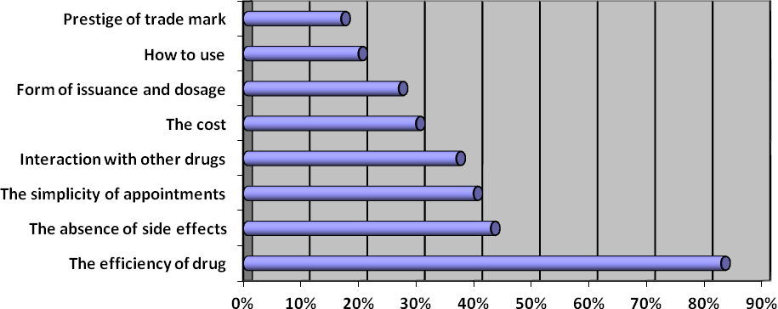
Fig. 1 Evaluation of significance of functional and other qualities of drugs

According to Figure 1, the most important feature of drugs that affect prescriptions, doctors have identified the effectiveness of drugs (83%), followed - absence of side effects (43%). The prestige of trade name has a minimal value for endocrinologists (17%).
Also as a result of questionnaires, we were able to identify which sources of information about drugs use in their work endocrinologists (Figure 2).
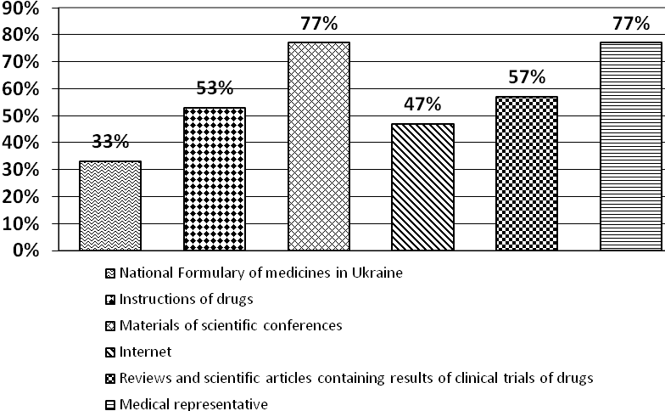
Fig. 2 Rating of informational sources about medicines

Found that most doctors give preference to information about drugs from materials of scientific conferences and to medical representatives. The least attention is paid to the National Formulary of medicines in Ukraine.
Conclusions
Not full use of nomenclature drugs by doctors may be caused by insufficient informing of available medicines on the pharmaceutical market of Ukraine.
The quality of treatment and prevention of such socially significant diseases as thyroid pathologies largely depends on the availability of drugs.

References
- Завгородня Т.П. Методи прогнозування [Електронний ресурс] / Т.П. Завгородня. – Режим доступу: http://lubbook.net/book_251.html. – 2014.
- Колкутин В.В. Об отборе экспертов для анализа конкурентоспособности аппаратно-технических средств для проведения судебных экспертиз / В.В. Колкутин, П.В. Пинчук, О.А. Васнецова // Проблемы экспертизы в медицине. – 2005. - № 17-1 (том 5). – С. 5-8.
- Левицька О.Р. Експертна оцінка лікарських засобів, які призначені для фармакотерапії інфаркту мозку / О.Р. Левицька, Б.П. Громовик, Н.П.Яворська, Г.М.Пришляк // Управління, економіка та забезпечення якості в фармації. – 2011. – № 6(20). – С. 52-58.
- Максимкина Е.А. Конкурентоспособность фармацевтические организации в условиях рынка / Е.А. Максимкина, Е.Е. Лоскутова, В.В.Дорофеева - М: МЦФЭР, 1999. - 256 с.
- Митник З. М. Стан ендокринологічної служби України в 2007 р. / З. М. Митник, Д. М. Панова, З. Г. Крушинська [та ін.] // Міжнародний ендокринологічний журнал. – 2008. – № 3(15). – С. 8-15.
- Січінава Р.М. Сучасні аспекти динаміки ендокринної патології серед військовослужбовців ЗС України / Р.М. Січінава, Б.І. Паламар, О.М. Іванько, В.В. Якимець // Вісник проблем біології і медицини. – 2014. – Т. 3 (112), № 3. – С. 192-195.
- Тронько Н. Д. Рак щитовидной железы у детей / Н. Д. Тронько. – Чернобыльинтеринформ, 1997. – 199 с.
- Хвороби щитоподібної залози. Довідник цікавих фактів та корисних знань. – Режим доступу: http://dovidka.biz.ua/hvorobi-shhitopodibnoyi-zalozi-zalozi/

Professor, Doctor of Biological Sciences Klishch Ivan Mykolaiovych
Ternopil State Medical University
1 Maidan Voli
Ternopil, 46003
Master of Clinical Pharmacy Zabihaylo Yulia Stepanivna
Ternopil State Medical University
5 Nalivaika street
Ternopil, 46003
E-mail: yuliavadziuk@mail.ru

