The article is published in Ukrainian in the journal.
The English text is given in the author's version.
UDC 615.12/.15
THE ANALYSIS OF THE IMPLEMENTATION OF PHARMACIST PROTOCOLS IN THE PRACTICAL ACTIVITIES OF PHARMACIES OF UKRAINE
O. M. Lischishina², O.O. Shylkina², V.Ye. Dobrova¹, V.V. Propisnova¹, T.Yu. Kolodyezna¹
¹ National university of pharmacy
² State Enterprise "State Expert Center of Ministry of public health of Ukraine"
Key words: pharmacist protocols, pharmaceutical care.
In recent years in Ukraine pharmacists protocols has actively developed and implemented in practical activities of the pharmaceutical industry professionals which are intended to unify the assistance to visitors of pharmacies in the framework of the concept of responsible self-medication. To assess the state of implementation of the standards developed as a pharmacist protocols it is needed to inspect constantly their practical use by pharmacists in their work. The article describes the results of a survey of practical pharmacy specialists, who work in the pharmacies of Ukraine and conducted their analysis. The results showed a broad awareness of the number of specialists in such concepts as pharmaceutical care, self-medication and the high interest of the respondents in the thematic literature on pharmaceutical care. The article pointed out that less than a half of the specialists were able to give a clear definition of "pharmacist protocols", but almost the same number of respondents could not give such a definition of this concept. It was concluded on the need to pay more attention to the training of specialists on this topic. Although most professionals are aware of the existence of such protocols, less than a half are guided by them in their practice. Regarding the availability of pharmacist protocols in pharmacies, it should be noted that they are available in less than a half of the institutions. These results indicate that the developed pharmacist protocols are not widely used by specialists of practical pharmacy in their work, so it is needed to carry out further work in their implementation in pharmacists everyday use in assistance to pharmacies visitors.

Introduction
According to the Concept of the development of pharmaceutical sector of Healthcare of Ukraine for 2011-2020 years [4] one of the tasks of pharmaceutical sector is a creation of appropriate legal framework to regulate the practice of pharmacy specialists [2].
The main aim of specialists work in pharmacies is to ensure the well-being of patients by promoting rational and economic purpose, appropriate use of medications, including OTC-drugs for symptomatic treatment according to the concept of responsible self-medication [2].
In recent years in Ukraine pharmacists protocols has actively developed and implemented in practical activities of the pharmaceutical industry professionals which are intended to unify the assistance to visitors of pharmacies in the framework of the concept of responsible self-medication [1,2,3,5,7,8]. The aim of protocols is to provide information support for pharmacists in the process of pharmaceutical care [6,9,10].
To assess the state of implementation of the standards developed as a pharmacist protocols it is needed to inspect constantly their practical use by pharmacists in their work.
So the aim of this work is monitoring of implementation of pharmacists protocols in the practical activities of pharmacies of Ukraine.

Materials and methods
The survey of 200 specialists of pharmacy who work in pharmacies of Ukraine was conducted for achieving this goal. The questionnaire contained general questions (age, education, position, region, experience and etc.) and questions about their level of preparedness in self-medication and pharmaceutical care, using existing regulations and thematic literature (pharmacists protocols, Ukrainian State Formulary and etc.) in their practice.
The survey was held from January till May 2014. The statistical analysis of the obtained results was held.
Results and discussion
The most of respondents (29,5 %) were specialists from Kharkiv region (Fig. 1). Also, compared to other regions, bigger number of respondents work in Lugansk (12 %), Dnipropetrovsk (9,5 %) and Poltava regions(8,5 %).

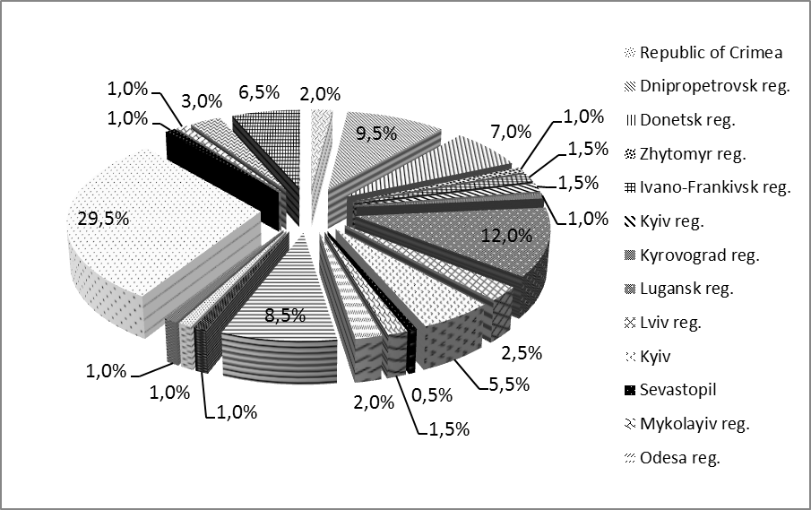
Fig. 1. Distribution of experts by region

The most of respondents (86,5 %) were aged 20-29 years and more than 40 years – 1 %. Most of specialists have 1 – 5 years of experience of working at pharmacies (Table 1). Among the respondents higher and collage pharmaceutical education have approximately the same number of specialists (35 % and 34 % in accordance), 25,5 % of them graduated from National university of pharmacy and near 22 % - from other collages. The most of respondents (68,5 %) work at private pharmacies.
Table 1
General characteristics of surveyed specialists (according to questionnaires)
General characteristics | Number of respondents (%)
Education
pharmaceutical collage | 68 (34)
higher pharmaceutical | 70 (35)
student | 2 (1)
no answer | 60 (30)
Age
20-29 years | 173 (86,5)
30-39 years | 22 (11)
more than 40 years | 2 (1)
no answer | 3 (1,5)
Experience of working at pharmacies
1 year | 75 (37,5)
1 – 5 years | 98 (49)
more than 5 years | 21 (10,5)
no answer | 6 (3)
Ownership of pharmacy where the respondent works
state | 37 (18,5)
private | 137 (68,5)
no answer | 26 (13)

According to the obtained results (table 2) most of specialists (79,5 %) work as a pharmacists who is getting higher education and as a pharmacist only 8 % of respondents.
Table 2
Positions on which respondents work
Position | Number of respondents (%)
pharmacist* | 160 (80)
pharmacist | 17 (8,5)
head of pharmacy | 6 (3)
senior pharmacist | 1 (0,5)
other positions** | 11 (5,5)
no answer | 5 (2,5)

* respondents who is getting higher pharmaceutical education
** respondents who is getting higher pharmaceutical education and stated their positions under staffing of pharmacies where they work (cashier, sales advisor and etc.)

The next part of questionnaire contained questions about specialists’ practice and their knowledge of some terms. The obtained results showed that 99,5 % of respondents know the term “self-medication”, and “pharmaceutical care”– 98,5 % (Fig. 2), but during the education process only 94,5 % of respondents studied pharmaceutical care; continue to be interested in literature on pharmaceutical care only 78,5 % of specialists.
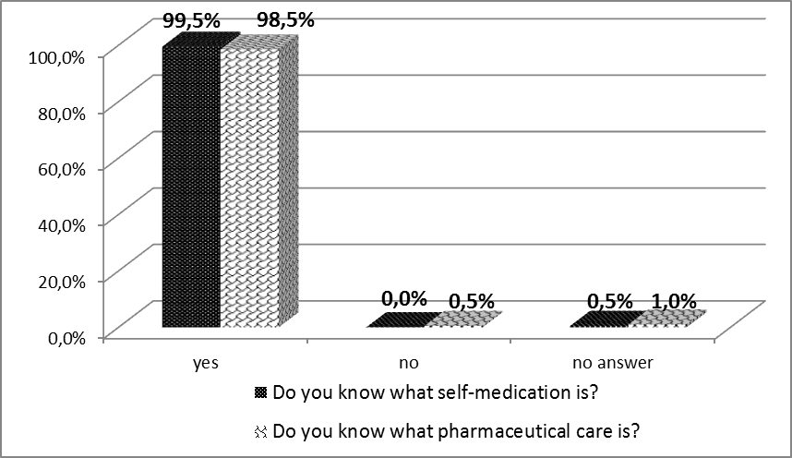
Fig. 2. Respondents' awareness about concepts of self-medication and pharmaceutical care

In one of the questions respondents needed to answer what exactly they are guided in their practice in dispensing of drugs to pharmacies’: 32,8 % of specialists stated “proper experience”, 40,6 % - knowledge from educational institution, 15,9 % - decrees of Ministry of Public Health of Ukraine, 10,2 % - cost of medicine (Fig. 3).
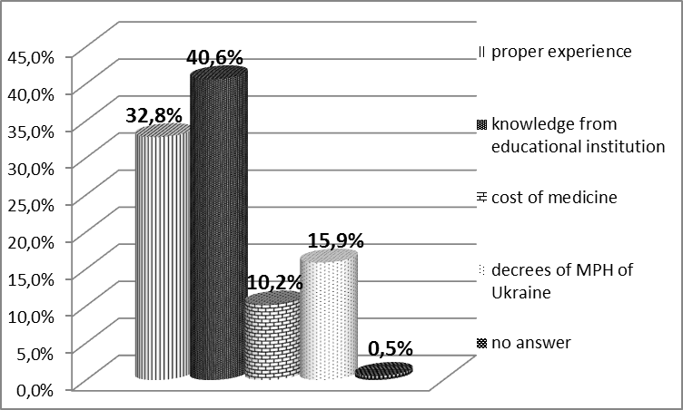
Fig. 3. Aspects which specialists are guided in dispensing of drugs
Pharmaceutical care implies consultation to visitor by a pharmacist, although not every visitor makes a purchase at pharmacy. Our research showed that 97,5 % of respondents consult visitors that make purchases, but only 60 % of pharmacists can consult more then 10 % of such visitors during the month (Fig. 4).
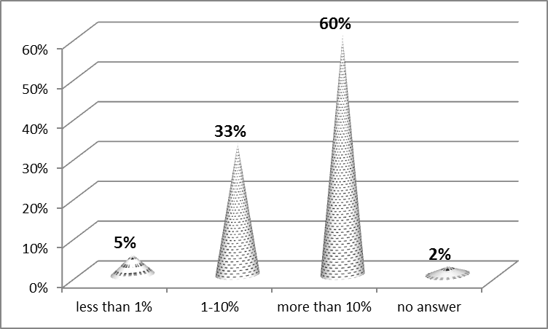
Fig. 4. Number of consulted visitors who bought medicine

For visitors that don’t do the purchase 93,5 % of specialists make consultations, but almost a half (49,5 %) of pharmacists give advice only to 1 – 10 % of such visitors during a month (Fig. 5).
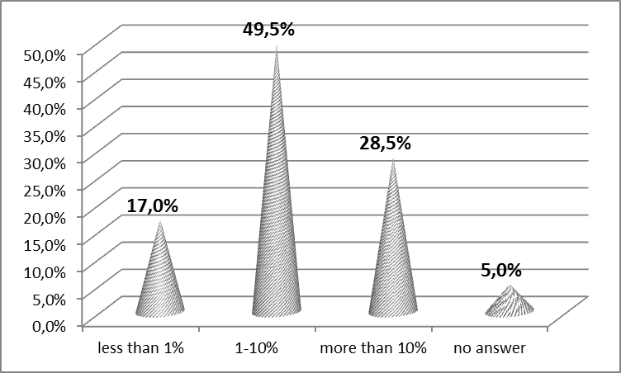
Fig. 5. Number of consulted visitors who didn’t bought medicine
Also, the questionnaire contained some questions about pharmacists’ work with the protocols as a standard of pharmaceutical care of patients during supply of OTC-drugs.
In the first of questions from this group respondents needed to mark the right definition of term “pharmacist protocols”. Only 43,5 % of respondents gave the right definition to this term (Fig. 6), but almost the same number of pharmacists (42 %) couldn’t give a clear definition to this term. This indicates that it’s needed to pay more attention on education of specialists on this topic, hold seminars or lectures on working with pharmacist protocols for pharmacists, other activities aimed at raising awareness of specialists on issues of responsible self-medication.

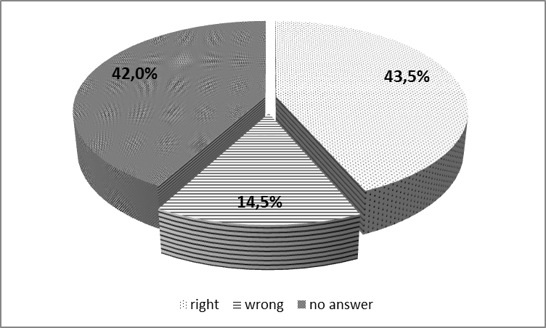
Fig. 6. The distribution of responses for correctness of definition to the term “pharmacist protocols”

Despite this outcome, 72 % of specialists answered that they know about the existence of such (table 3), protocols have seen even less – only 56,5 %, and guided by them at work only 46,5 %. About the availability of pharmacists protocols in pharmacies should be noted that they are only in 45,5 % of them, and drugs included in the protocols available at 62,5 % of pharmacies. Only 22,5 % of respondents stated that protocols are comfortable for their practical use. This results show that pharmacist protocols aren’t widely used in practice during supply of drugs to pharmacies’ visitors.
Table 3
The analysis of some aspects of respondents’ work with pharmacist protocols
Aspect | Number of respondents (%)
Do you know about the existence of pharmacist protocols?
yes | 144 (72)
no | 52 (26)
no answer | 4 (2)
Are there pharmacist protocols at your pharmacy?
yes | 91 (45,5)
no | 53 (26,5)
don't know | 52 (26)
no answer | 4 (2)
Did you see the pharmacist protocols?
yes | 113 (56,5)
no | 85 (42,5)
no answer | 2 (1)
Are you guided by pharmacist protocols in your work?
yes | 93 (46,5)
no | 100 (50)
no answer | 7 (3,5)
Are the pharmacist protocols comfortable for use?
yes | 45 (22,5)
no | 5 (2,5)
don't know | 68 (34)
no answer | 82 (41)
Are drugs included in the protocols available at your pharmacy?
yes | 125 (62,5)
no | 9 (4,5)
don't know | 56 (28)
no answer | 10 (5)

CONCLUSIONS
Since the pharmacist protocols haven’t become widely used in practice during supply of OTC-drugs so it’s needed to provide further work on their implementation to everyday practice of pharmacists in their work with visitors of pharmacies. The further development of protocols should be done, because they are an important informational tool in the objectives of the pharmaceutical worker. Also it’s needed to develop effective tools for monitoring the implementation process of the pharmacist protocols in specialists everyday practice in Ukraine.

LITERATURE
- Зіменковський А. Б. Концепція DRP як частина філософії раціональної фармакотерапії, інтегрованої з системою фармацевтичної опіки / А. Б. Зіменковський, Т. Б. Ривак, Н.Л. Ханик //Клінічна фармація, фармакотерапія та медична стандартизація. – 2011. – №1-2. – С.23-31.
- Зупанець І. А. Протоколи провізора (фармацевта) – важлива складова системи стандартизації медичної допомоги / І. А. Зупанець, О. М. Ліщишина, О. О. Шилкіна, Н. В. Бездітко, В. Є. Доброва // Управління, економіка та забезпечення якості в фармації. – 2015. - № 3 (41). – С. 12-16.
- Наказ МОЗ України від 30.05.2013 № 455 «Про настанову ВООЗ та МФФ «Належна аптечна практика: Стандарти якості аптечних послуг».
- Наказ МОЗ України від 13.09.2010 № 769 «Про затвердження Концепції розвитку фармацевтичного сектору галузі охорони здоров’я України на 2011-2020 роки».
- Опека пациента в практике врача и провизора. Руководство по применению лекарственных средств: пособие /под ред. И.А. Зупанца, В.П.Черных. – Киев, 2011. – 480с.
- Протоколи провізора (фармацевта). Інформаційний посібник МОЗ України / розробники: В.П. Черних, І.А. Зупанець, О.О. Нагорна та інш. – Х., Золоті сторінки, 2014. – 232 с.
- Hepler C. D. Clinical pharmacy, pharmaceutical care, and the quality of drug therapy // Pharmacotherapy. — 2004. — Vol. 24(11). — P. 1491-1498.
- Joint FIP/WHO guidelines on good pharmacy practice: standards for quality of pharmacy services. WHO Technical Report Series, No. 961, 2011. — Geneva: World Health Organization, 2011. — 18 p. http://www.fip.org/good_pharmacy_practice
- The impact of pharmaceutical care practice on the practitioner and the patient in the ambulatory practice setting: twenty-five years of experience / L. M. Strand, R. J. Cipolle, P. C. Morleyetal //Curr. Pharm. Des. — 2004. — Vol. 10(31). — P. 3987-4001.
- The role of the pharmacist in the health care system. Preparing the future pharmacist: Curricular development. Report of a third WHO Consultative Group on the role of the pharmacist. — Geneva: World Health Organization; 1997 // http: www.who.int/medicinedocs

