The article is published in Russian in the journal.
The English text is given in the author's version.
UDC615.276+615.212]:615.454.1

DEVELOPMENT OF MELOXICAM GEL COMPOSITION ON THE BASIS OF BIOPHARMACEUTICAL RESEARCH RESULTS

Bezuglaya E.P. ¹, Lyapunov A.N. ¹, Libina V.V. ², Orlova I.N. ², Kudris I.V. ³

¹ State Scientific Institution «Institute for Single Crystals» of National Academy of Sciences of Ukraine»
² State Enterprise «State Scientific Center of Medicinal Products and Medical Devices»
³ State Enterprise «State Expert Center of the Ministry of Health of Ukraine»

Keywords: meloxicam, gel, analgesic effect, anti-inflammatory effect, release, pharmacokinetics

Meloxicam concentration and composition of the permeation enhancers in gel for cutaneous application was chosen on the basis of the results of pharmacological screening using a model of acute aseptic carrageenan inflammation of rat feet. The efficacy of analgesic effect of gels increases with increasing the meloxicam content, and the efficiency of anti-inflammatory activity passes through a maximum at meloxicam concentration of 1.0-1.5%. Efficacy of anti-inflammatory and analgesic effects is the highest when gels contain 15 % of N-methylpyrrolidone and 25 % of ethanol (96 %). Gel base possess the osmotic activity, whereby providing the water absorption by the drug and prolonged release of meloxicam from gels in experiments in vitro, which is an important prerequisite for its transdermal absorption. In experiments on rabbits it was found that in case of gel cutaneous application meloxicam is being absorbed slowly and continuously into the systemic circulation at a relatively high extent of transdermal absorption and slow elimination; therefore, effective prolonged therapeutic action can be expected.

During pharmaceutical development of new drugs it is necessary to perform evidence-based selection of the active substance and excipients. The active substance concentration in the semi-solid preparations (SSP) for cutaneous application as well as the type and composition of the base should be justified, thus providing functional characteristics of the drug, the effectiveness of the pharmacological action, safety and, if necessary, the bioavailability. However, as the new drugs should be understood not only drugs with new substances, but also drugs with known active ingredients in different dosage forms that require other routes of administration [1]. Selection the active substance and its concentration for a new drug as well as the type and composition of its vehicle should be based, inter alia, on the results of complex biopharmaceutical studies with experiments in vitro and in vivo [2].
There are gels for cutaneous application containing various non-steroidal anti-inflammatory drugs (NSAIDs) [3, 4, 5]. Meloxicam is safe and effective NSAID – a selective inhibitor of COX-2 [3]. Until 2014, the World nomenclature of meloxicam formulations included solutions for injection, tablets and rectal suppositories, whereas there were no meloksikam gels for cutaneous application [3, 4, 5]. In these gels meloxicam must be in a solution that allows meloxicam releasing, transdermal transport and specific anti-inflammatory and analgesic effect providing. If meloxicam in the SSP is in the form of suspension, it is practically not released during the experiments in vitro; such preparations may be expected to provide a specific effect only on the skin [6]. Therefore, biopharmaceutical research to develop meloxicam gel for cutaneous application, wherein the meloxicam would be in the form of a solution, were of the current interest.
The purpose of this work is to choose rational concentrations of meloxicam in the gel and the composition of penetration enhancers based on the results of pharmacological screening, to research of meloxicam release in experiments in vitro, as well as to conduct a comparative study of its pharmacokinetic properties, confirming its transdermal transport.
Materials and methods
Gels of varying composition, containing, as gelling agent Carbopol®Ultrez 21 Polymer («Lubrizol Advanced Materials») [7] at a concentration of 0.9 % and having a pH from 7.5 to 9.0 were the objects of study. Meloxicam («ULKAR KIMYA Sanayii Ve Ticaret A.S.») [3, 8], trometamol («Merck», Cat. Number 108 386), ethanol (96%), N-methylpyrrolidone (N-MP) («Ashland Speciality Ingredients»), propylene glycol, purified water [8] were used in the gel compositions. Meloxicam in gels is in dissolved salts with trometamol.
Meloxicam trometamol release from gels was determined in experiments in vitro by dialysis through a cellophane membrane (GOST 7730-89) at a temperature (32 ± 0.1) °C [9], and its assay in the dialysate was determined by spectrophotometry method (ultraviolet and visible) [8 ]. The absorption spectra were recorded using spectrophotometer «PharmaSpec UV-1700» («Shimadzu», Japan) with software «UV Probe» version 2.21; absorbance was measured at a absorption maximum at a wavelength of 364 nm. The concentration (C) of meloxicam in the solution was calculated by:
,
where C – the concentration of meloxicam g/100 ml; A – the absorbance of the test solution; – meloxicam specific absorpbance, which at a wavelength of 364 nm is equal to 490.26 ± 0.35; b – path lenght, in centimeters; r – dilution.
In the range of concentrations from 0,000214 % w/v to 0,003198 % w/v (from 2.14 µg/ml to 31.98 µg/ml), the dependence of the absorbance of the meloxicam content is linear (correlation coefficient r = 0, 99995).
The kinetics of absorption of water by the gel was determined in experiments in vitro by dialysis through a cellophane membrane (GOST 7730-89) at a temperature (32 ± 0.1) °C [11]. Initially, the gel amount in the chamber for dialysis was 3.0 g
The anti-inflammatory and analgesic actions of meloxicam gels were investigated using model of acute aseptic carrageenan inflammation of rats feet [11] compared to comparators Voltaren Emulgel 1% («Novartis Consumer Health SA») and Nimulid gel 10 mg/g («Panacea Biotec») [3, 4, 5 ]. Research conducted on nonlinear adult male rats weighing 140-220 g (average 180 g). Samples of gel were applied on the skin of the foot to the ankle of rats twice in an amount of 100 mg: 30 minutes before flogistic injection and immediately after injection; total amount of gel was 200 mg for each rat. Exudative edema was induced by injection into the right hind foot of rats of 0.08 ml of a 0.5% aqueous solution of carrageenin 30 minutes after the first application of the gel.
Pain threshold (PT) was recorded in 3 hours and 5 hours after injection flogistics by Randall-Selitto method with mechanical pain stimuli using analgezimeter (mod. 7200, Ugo Basile, Italy). The analgesic effect (AE) was calculated taking into account increase the PT in rats which were applied gels, as compared with control untreated animals, calculating using the formula:
AE = [(F_{e} – F_{c} ) / F_{c}] × 100 %,
where F_{e} and F_{c} – the threshold force of pressure on the foot (g) in the experimental and control groups, respectively.
The anti-inflammatory effect was evaluated by the degree of edema growth of the foot on the background of drug applications compared to the control group of untreated animals. The volume of the foot was measured before and after 1 hour, 3 hours (at the peak of edema) and 5 hours after injection of flogistic using electronic plethysmometer (mod. 7150, Ugo Basile, Italy). Anti-inflammatory effect (AIE) was calculated using the formula: ПЭ = [(ΔV_{c} – ΔV_{e}) / ΔV_{c}] × 100 %,
AIE = [(ΔV_{c} – ΔV_{e}) / ΔV_{c}] × 100 %,
where ΔV_{c} and ΔV_{e} – the average increase in the volume of edematous foot in control and experimental groups, respectively.
The total analgesic effect (ΣAE) and overall anti-inflammatory effect (ΣAIE) gels as the area under the curve «time effect» were calculated. Statistical analysis was performed by conventional methods in pharmacology [12].
Pharmacokinetic studies of meloxicam gel 1% were conducted by singly applied to the skin of rabbits compared to the intramuscular (i/m) administration of Movalis injection of 15 mg/1.5ml («Boehringer Ingelheim») [3, 4, 5 ]. Experiments were conducted on unanesthetized adult chinchilla rabbits of both sexes weighing 3,7±0,5 (3,7÷5,7) kg. One day before applying the gel skin area of ​​100 cm² (10 cm×10 cm) on the back of rabbits was depilated. On the prepared area of ​​skin 1g of the meloxicam gel was applied per 1 kg of body weight; this amount of gel corresponds to meloxicam dose of 10 mg/kg. Blood for analysis was collected from the marginal ear vein of a rabbit in heparinized tubes before drug application and in 2; 4; 6; 8; 12; 18; 24; 28; 33; 48; 54 and 72 hours after application. Comparator was administered into the femoral muscle of rabbits in the volume of 0.2 ml per 1 kg of body weight, this amount of Movalis injection corresponds to 2 mg/kg of meloxicam. Blood for analysis was taken from ear marginal vein of rabbit before administration and in 0,083; 0.25; 0.5; 0.75; 10; 15; 4; 6; 8; 24 and 30 hours after administration. The blood was centrifuged at 3000 rpm for 5 min. The resulting plasma was stored at temperature minus 22°C until conduct analytical procedures.
The concentration of meloxicam in blood plasma of rabbits was determined by the developed procedure which includes solid phase extraction (SPE) of active substance from the plasma, vacuum sample concentration and determination the meloxicam content by high performance liquid chromatography method (HPLC).
While preparing frozen plasma samples were unfreezed at room temperature. 60 µl of the internal standard (piroxicam solution in methanol 550 µg/ml) and 40 µl of 4 M hydrochloric acid solution were added to 1.0 ml of plasma, prepared samples were centrifuged for 7 minutes at 6000 rpm at room temperature, then 1 ml of supernatant from each sample was transferred to previously equilibrated cartridges for SFE (Oasis – HLB 1ml, 30 mg, «Waters»). After washing off endogenous substances of plasma from cartridge (twice with 2 ml of water, once with 1 ml of 10 % methanol) elution meloxicam and piroxicam was performed (1 ml of 5 % ammonia solution in methanol). The eluate was evaporated to dryness under vacuum at a temperature of 59 °C. Solid residue was dissolved in mobile phase (250 µl).
Analysis was performed using HPLC-system «Agilent 1200» 2DLC system (USA). Chromatographic conditions: chromatographic column – ZORBAX Eclipse XDB-C18, size of 150x4.6 mm, particle diameter − 5 µm; precolumn – ZORBAX Eclipse XDB-C18, size of 12.5x4.6 mm, particle diameter −5 µm; mobile phase – acetonitrile – triethylamine solution( 4:6 (v/v)) adjusted to pH 2.5 with phosphoric acid; detection at wavelength of 355 nm; temperature of the thermostat column – 35 °C; autosampler thermostat temperature – 16 °C; flow rate of – 1.2 ml/min; injection – 80 µl. Meloxicam retention time is 9÷10 min, run time – 13 min.
Validation of analytical procedure for assay of meloxicam in rabbits plasma was conducted concerning such characteristics as «selectivity», «lower limit of quantification», «linearity», «precision», «accuracy» and «extraction rate» in view of the criteria for bioanalytical chromatographic methods [13, 14, 15] .
These conditions of the chromatographic sample preparation provide: selective determination of meloxicam and internal standard in rabbits plasma; the lower limit of quantitation of meloxicam in plasma 50 ng/ml; linearity of calibration curve within range of concentrations from 50 ng/ml to 20,000 ng/ml (regression coefficient r=0,9999); the precision of the method (as the coefficient of variation) in mentioned range of concentrations – from 0.87 % to 3.29 %; the accuracy (as the relative error in relation to the nominal values of concentration) – from minus 0.90 % to minus 3.24 %; an average extraction rate of meloxicam from plasma – 89.7 %, extraction rate of the internal standard – 92.7 %. That is, the main validation parameter of the developed method meets the acceptance criteria for bioanalytical methods.

Results and Discussion
In order to choose meloxicam concentration and composition of permeation enhancers the pharmacological screening of anti-inflammatory and analgesic effect of gels was conducted. Under conditions of acute aseptic carrageenan inflammation of the rats foot [11] gels samples provide anti-inflammatory and analgesic effects of different degrees of severity depending on the content of meloxicam (table 1). Anti-inflammatory and analgesic effects of gels with increasing concentrations of meloxicam ranging from 0.5 % to 1.5 % increase. Though, the meloxicam concentration of 0.5 % proved to be unacceptable because of low efficiency of the anti-inflammatory and analgesic action. The total inflammatory and analgesic effects of gels containing 1.0 % and 1.5 % of meloxicam are close to each other and differ in 1.1 and 1.2 times respectively. Increasing the meloxicam concentration to 2.0 % leads on the one hand, to an increase in the total analgesic effect, and, on the other hand, to a paradoxical effect – considerable decrease of anti-inflammatory activity (table. 1), which was confirmed in several experimental series.
Table 1
Anti-inflammatory effect (AIE) and the analgesic effect (AE) of gels containing meloxicam at various concentrations (C) and having different composition of permeation enhancers (PE), compared with comparators

С,  % | Content PE,% |  |  | AIE (%) in: |  |  | Σ AIE,  %·h | AE (%) in: |  | Σ AE,  %·h
С,  % | N-MP | Ethanol | PG | 1 h | 3 h | 5 h | Σ AIE,  %·h | 3 h | 5 h | Σ AE,  %·h
0,5 | 15 | 25 | 0 | 0 | 4,8 | 9,1 | 18,7 | 9,3 | 5,7 | 29,0
1,0 | 15 | 25 | 0 | 32,9 | 27,5 | 27,8 | 132,2 | 55,3 | 12,5 | 150,8
1,5 | 15 | 25 | 0 | 28,2 | 37,0 | 26,0 | 142,3 | 62,9 | 18,5 | 175,8
2,0 | 15 | 25 | 0 | 14,9 | 15,2 | 10,5 | 63,3 | 81,9 | 25,1 | 229,9
1,0 | 15 | 25 | 0 | 32,9 | 27,5 | 27,8 | 132,2 | 55,3 | 12,5 | 150,8
1,0 | 0 | 40 | 0 | 33,7 | 17,3 | 22,8 | 108,0 | 24,2 | 0 | 60,5
1,0 | 15 | 0 | 25 | 25,7 | 19,4 | 19,2 | 96,6 | 30,1 | 7,0 | 82,3
Voltaren Emulgel 1% |  |  |  | 14,2 | 38,6 | 36,0 | 134,5 | 11,5 | 19,8 | 48,6
Nimulid gel 10 mg/g |  |  |  | 1,7 | 28,3 | 26,3 | 85,5 | 30,1 | 32,3 | 107,6
Note: Σ AIE – total AIE; Σ AIE – total AIE.

According to the research results rational meloxicam concentration in gel is 1.0 %.
Taking into account the results of pharmacological screening, the most promising is using as permeation enhancers mixed solvent which consists of 15 % N-MP and 25 % ethanol (96 %) and provides the most effective anti-inflammatory and analgesic action of meloxicam gel 1.0 % (table 1). If 15 % N-MP is excluded from permeation enhancers and replaced with ethanol (96 %) and if in a mixed solvent ethanol (96 %) is replaced with propylene glycol the total inflammatory effects of meloxicam gels 1 % are reduced accordingly by 1.2 times and 1.4 times, and their total analgesic effects – by 2.5 times and 1.8 times (table 1).
Total inflammatory effect of samples of 1.0 % meloxicam gels containing as permeation enhancers 15 % N-MP and 25 % ethanol (96%), approximately corresponds to the total anti-inflammatory effect of the Voltaren Emulgel 1% (132.2 %•h and 134.5 %•h respectively), but exceeds its total analgesic effect by 3.1 times (150.8 %•h and 48.6 %•h respectively) (table 1). Total anti-inflammatory effect of these samples of 1.0 % meloxicam gels exceeds anti-inflammatory effect of the Nimulid gel 10 mg/g by 1.5 times (132.2 %•h and 85.5 %•h, respectively), and the total analgesic effect by 1,4 times (150,8 %•h and 107,6 %•h, respectively) (table 1).
Pharmacological screening results show that when the gel contains 1.0 % meloxicam trometamol (calculated to meloxicam) as well as 15 % N-MP and 25 % ethanol (96%) the medicinal product possess a balanced performance of anti-inflammatory and analgesic effects and has advantages over comparators containing 1 % of diclofenac diethanolamine (calculated to diclofenac sodium) and 1 % of nimesulide.
Due to presence of the hydrophilic solvents and carbomer salt the product is hypertensive. Osmolality measurement of gel using osmometer-cryostat is impossible due to its freezing temperature below minus 10 °C. Therefore, increased osmolality of the drug was judged indirectly on the kinetics of diffusion through a semi-permeable membrane.
A prerequisite for specific pharmacological action of meloxicam is its release from the dosage form. The meloxicam diffusion through a semi-permeable membrane into a camera with water relatively models its passive diffusion through the skin. For the release all the necessary preconditions have been createded: meloxicam is in dissolved form, the gel possess a high osmolality and it conteins permeation enhancers. As follows from fig. 1, the concentration of meloxicam in the dialysate rises rapidly during the first 4 hours, then the release rate is reduced and the release is prolonged to 24 hours. The pH of the gels in the range from 7.5 to 9.0 does not influence the release kinetics of meloxicam (fig. 1).
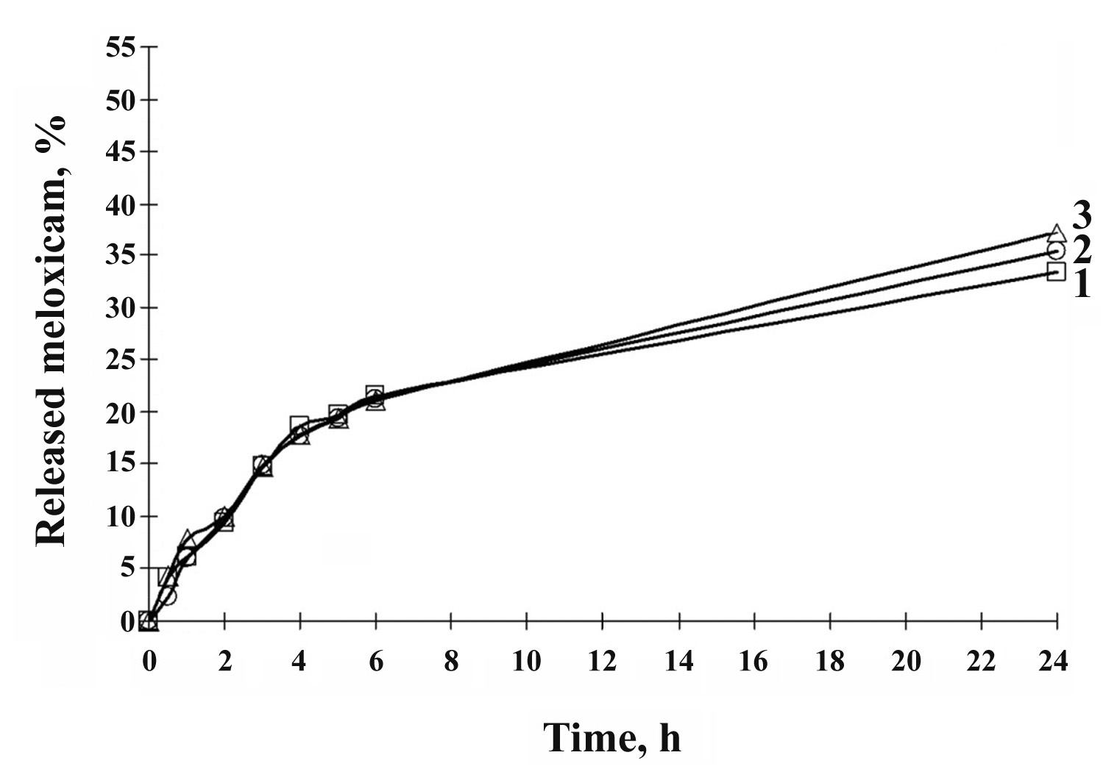
Fig. 1. Kinetics of meloxicam release from 1 % gels with pH of 7.54 (1), 8.25 (2) and 9.03 (3) in experiments in vitro at a temperature of 32 °C
Diffusion processes arising from differences in osmotic pressure between the chambers separated by a semi-permeable membrane, should be viewed in two opposite directions: the release of dissolved substances into the chamber with water and the diffusion of water into the chamber with the drug. Weight of chamber with the drug increases in 0.5 h – 27.9 %, 1.0 h – 44.0 %, 2.0 h – 66.8 %, 3.0 h – 82.5 %, 4.0 h – 102.8 % 5 h – 112.9 % and 6 h – 123 % (fig. 2). In other words, there is a prolonged moderate water absorption. The risk of side effects associated with the dehydrating action of the drug on the skin with such absorption is actually absent.
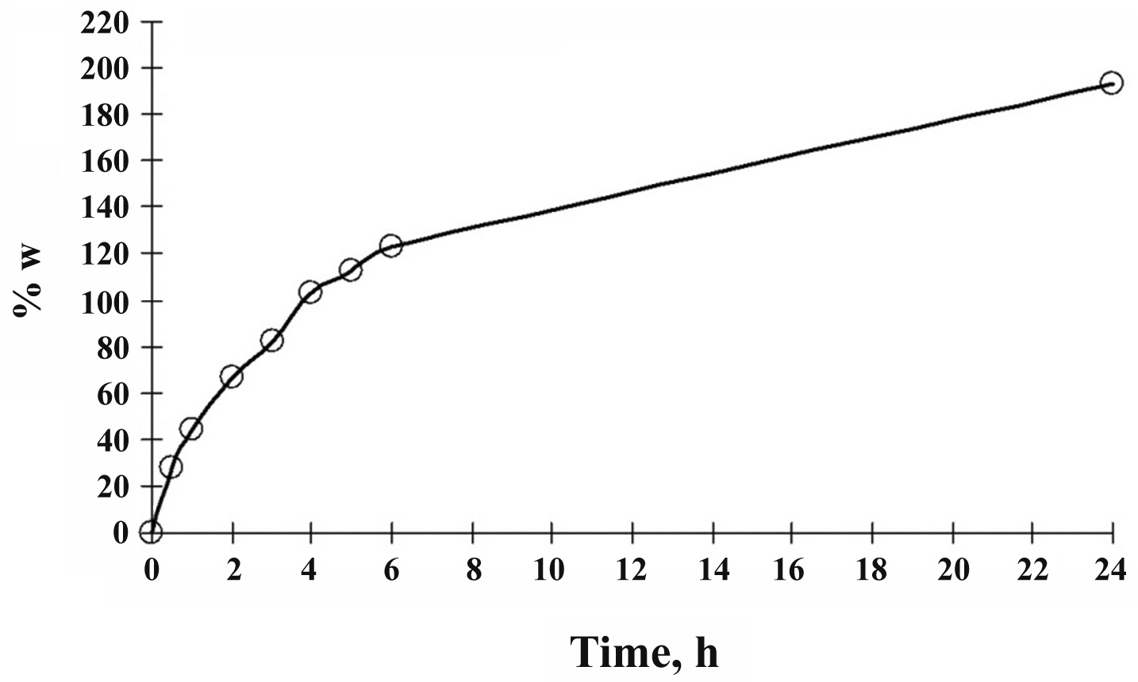
Fig. 2. The kinetics of water absorption experiments invitro of 1% gel at 32 ° C.
The developed gel base ensures transdermal absorption of meloxicam as shown in the experiments on rabbits. As shown in table 2, fig. 3 and table 3, the process of absorption of meloxicam from the gel into the systemic circulation is prolonged. The time to reach maximum concentration defined by the ratio of absorption rate and elimination rate is high (12 hours) and demonstrates a long and gradual absorption of meloxicam. Meloxicam after cutaneous application continuously circulates in the blood and slowly eliminate: MRT = 26,9 h; K_{el} = 0.0332 h⁻¹; T_{1/2} – 20.87 h.
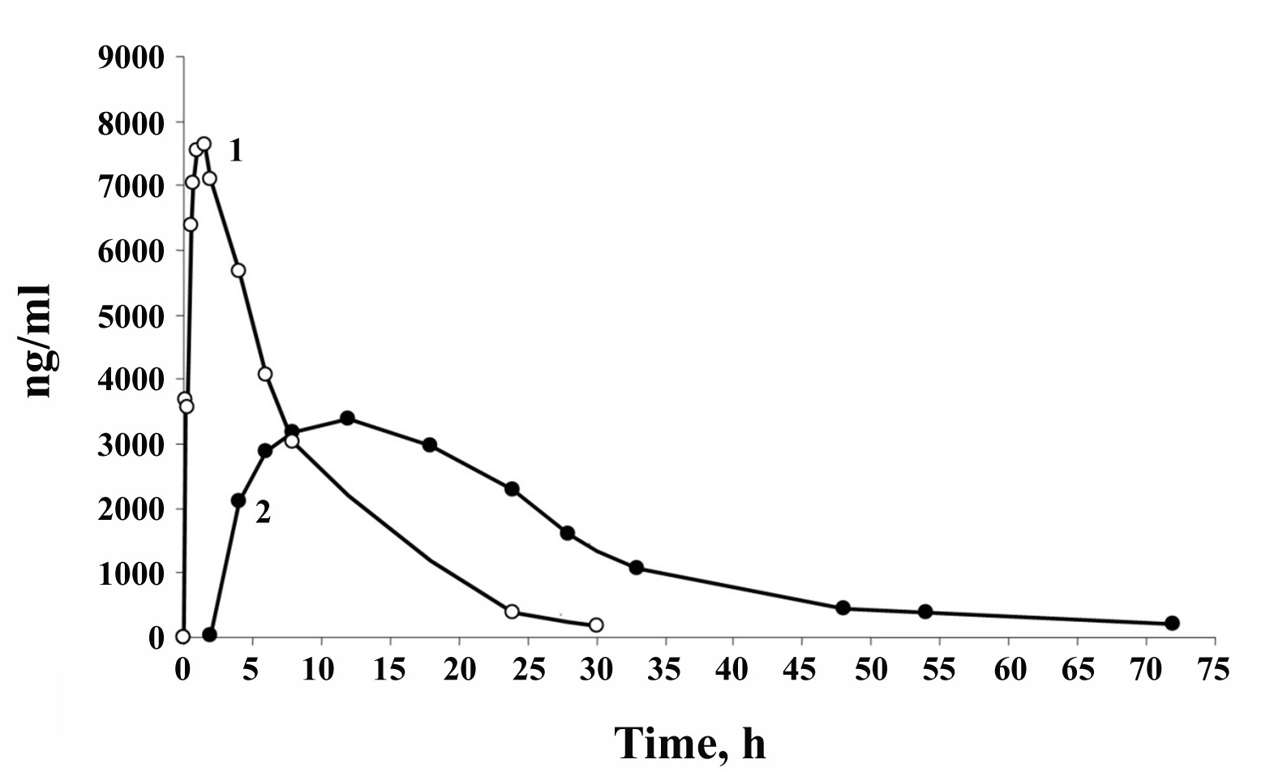
Fig. 3. Pharmacokinetic curves for meloxicam after cutaneous application of the gel at a dose of 10 mg/kg (1) and after intramuscular administration at a dose of 2 mg/kg (2).

Table 2
The concentration (C) of meloxicam in plasma of rabbits after a single i/m administration of Movalis injection 15 mg/1,5 ml
and a single cutaneous application of the 1% meloxicam gel

С (ng/ml) in …h after the i/m administration of Movalis injection 15 mg/1,5 ml at a dose of 2 mg/kg
№ | 0 | 0,083 | 0,25 | 0,5 | 0,75 | 1 | 1,5 | 2 | 4 | 6 | 8 | 24 | 30
1 | 0,0 | 9527,6 | - | 12044,0 | 3536,0 | 10642,2 | 9199,2 | 8135,1 | 5774,3 | 4105,8 | 3263,2 | 398,8 | 243,4
2 | 0,0 | 806,1 | 1765,7 | 3646,3 | 11948,5 | 6881,1 | 8262,9 | 8401,3 | 7981,8 | 5445,1 | 4187,8 | 480,9 | 211,7
3 | 0,0 | 938,7 | 2311,0 | 3554,4 | 4965,5 | 5654,6 | 5657,5 | 5530,6 | 3614,4 | 2193,8 | 1521,2 | 234,7 | 69,7
4 | 0,0 | 3241,2 | 4891,9 | 6006,1 | 6646,5 | 6089,5 | 5830,5 | 5111,1 | 3597,4 | 2542,0 | 1736,9 | 138,2 | 61,1
5 | 0,0 | 3914,7 | 5234,9 | 6606,4 | 8104,9 | 8470,6 | 9203,1 | 8328,9 | 7428,3 | 6068,2 | 4421,2 | 726,5 | 359,8
Mean | 0 | 3685,6 | 3550,9 | 6371,4 | 7040,3 | 7547,6 | 7630,6 | 7101,4 | 5679,2 | 4071,0 | 3026,0 | 395,8 | 189,1
S.E. | ˗ | 1584,6 | 789,9 | 1544,9 | 1448,6 | 910,6 | 789,5 | 731,2 | 921,1 | 766,2 | 603,3 | 102,2 | 56,2
С (ng/ml) in …h after cutaneous application of the 1% meloxicam gel at a dose of 10 mg/kg
№ | 0 | 2 | 4 | 6 | 8 | 12 | 18 | 24 | 28 | 33 | 48 | 54 | 72
1 | 0,0 | 80,4 | 8766,0 | 10114,1 | 9353,1 | 3160,9 | 1681,8 | 1859,4 | 1170,5 | 802,9 | 435,5 | 417,3 | 160,0
2 | 0,0 | 0,0 | 581,3 | 1218,6 | 1655,2 | 4785,2 | 2316,8 | 3379,7 | 2717,1 | 1930,9 | 648,5 | 557,7 | 280,5
3 | 0,0 | 0,0 | 311,8 | 1337,1 | 1934,7 | 4842,7 | 4727,4 | 1741,1 | 978,8 | 749,4 | 423,6 | 282,7 | 247,3
4 | 0,0 | 0,0 | 76,4 | 252,5 | 605,1 | 3754,2 | 2652,9 | 2851,5 | 1958,0 | 1087,6 | 421,9 | 355,0 | 183,5
5 | 0,0 | 0,0 | 756,5 | 1495,1 | 2290,6 | 353,5 | 3445,0 | 1557,9 | 1162,9 | 732,1 | 320,2 | 295,0 | 152,6
Mean | 0 | 16,1 | 2098,4 | 2883,5 | 3167,7 | 3379,3 | 2964,8 | 2277,9 | 1597,5 | 1060,6 | 450,0 | 381,5 | 204,8
S.E. | ˗ | 16,1 | 1670,9 | 1820,6 | 1571,7 | 820,4 | 524,4 | 355,3 | 326,9 | 226,9 | 53,8 | 50,1 | 25,2

Table 3
The main pharmacokinetic parameters of meloxicam
in case of intramuscular injection and cutaneous application to rabbits
Pharmacokinetic parameters | Values of pharmacokinetic parameters
Pharmacokinetic parameters | I/m administration | Cutaneous application
Dose, mg/kg | 2 | 10
C_{max}, ng/ml | 7630,6 | 3379,3
T_{max}, h | 1,5 | 12
CL, ml/h | 27,31 | 99,32
K_{el}, h⁻¹ | 0,1263 | 0,0332
Т_{1/2}, h | 5,49 | 20,87
MRT, h | 7,09 | 26,93
V_{z}, ml/kg | 216,31 | 2991,05
АUС_{0→t}, ng•h/ml | 71731,89 | 94514,9
АUС_{0→∞}, ng•h/ml | 73229,60 | 100682,30
С_{max}/АUС _{0→t}, h⁻¹ | 0,1064 | 0,0358
f’, % | 100 | 26,4
When injecting a solution and cutaneous applying a gel, concentrations of meloxicam in blood as well as character of pharmacokinetic curves differ (fig. 3). The rate of meloxicam absorption when cutaneous application lower than after intramuscular administration by about 3 times and the half-life 3.8 times longer, which leads to a corresponding prolongation of retention time in the body. The maximum concentration of meloxicam when cutaneous application of the gel is 11 times lower than for intramuscular injection in view of the dose administered. At the same time its relative bioavailability (f') is 26.4 % compared to intramuscular injection and it is sufficiently high as for a drug with transdermal absorption.
Pharmacokinetics of meloxicam when cutaneous application of the gel is characterized by slow and prolonged absorption into the systemic circulation at a relatively high extent of transdermal absorption and slow elimination, allowing to predict an effective and prolonged therapeutic effect.
The research results were part of the pharmaceutical development of medicinal product Amelotex gel for cutaneous application 1% (reg. PL-002 479; the applicant – JSC «PharmFirma «Sotex») [5]), the product was introduced in industrial production in August 2014 (the manufacturer – JSC «Ozone»).
CONCLUSIONS
1. On the basis of pharmacological screening result using the carrageenan model of acute aseptic inflammation of rat foot the concentration of meloxicam and composition permeation enhancers in gel for cutaneous application was selected. It is shown that the efficiency of analgesic effect increases with increasing of meloxicam content in gel, and the efficiency of anti-inflammatory activity passes through a maximum at meloxicam concentration of 1.0-1.5 %. Efficacy of anti-inflammatory and analgesic effects is the highest when the gel contains 15 % of N-methylpyrrolidone and 25 % of ethanol (96 %).
2. In experiments in vitro using the method of dialysis through a semi-permeable membrane it was showed that the gel base possess the osmotic activity, whereby provides a moderate water absorption by drug and prolonged release of meloxicam from the gel, which is an important prerequisite for its transdermal absorption.
3. In an experiment on rabbits it was found that when cutaneous applying gel meloxicam is being slowly and continuously absorbed into the systemic circulation at relatively high extent of transdermal absorption and slow elimination, therefore, effective prolonged therapeutic action can be expected.

REFERENCES
1. The Rules Governing Medicinal Products in the European Union. – The Notice to Applicants. – Volume 2C. Regulatory Guidelines. – Guideline on the Categorisation of Extension Applications (EA) versus Variations Applications (V). – European Comission. – Brüssels, F2/AW D(2002), Final – Revision 3.
2. EMEA/СHМР/167068/2004 – ICH. – Part I. – ICH Topic Q 8 (R2). – Step 5: Note for Guidance on Pharmaceutical Development, 2009.
3. Martindale: The Complete Drug Reference. 36th Edition / Ed. Sweetman S.С. – London: Pharmaceutical Press, 2009. – 3694 p.
4. Державний реєстр лікарських засобів України [Електронний ресурс]. Режим доступу: http://www.drlz.kiev.ua/
5. Государственный реестр лекарственных средств России [Электронный ресурс]. Режим доступа: http://grls.rosminzdrav.ru/

6. Глава 9. Фармацевтическая разработка лекарственных препаратов / Ляпунов Н.А., Безуглая Е.П., Столпер Ю.М. и др. // Аналитическая химия в создании, стандартизации и контроле качества лекарственных средств (в 3 томах) / Под ред. В.П. Георгиевского. – Том 3. Метрологическое и нормативное обеспечение создания, производства и контроля качества лекарственных средств. – Харьков: Изд-во «НТМТ», 2011. – Т. 3. – С. 1419-1512.
7. Carbopol® Ultrez 21 Polymer // Technical Data Sheet (TDS-297). – Cleveland: Lubrizol, 2002. – 4 p.

8. European Pharmacopoeia. 8th Edition. – European Directorate for the Quality of Medicines (EDQM). – Council of Europe, 67075 Strasbourg Cedex, France 2013. – 3655 p.
9. Lugano A.S. Etude du transport de principles actifs incorpores dans des emulsions liquides de type huile dans eau: These doct. pharm. sci. – 1793. – Zurich, 1977. – 117 s.
10. Методические рекомендации по экспериментальному (доклиническому) изучению лекарственных препаратов для местного лечения гнойных ран / Даценко Б.М., Калиниченко Н.Ф., Лепахин В.К. и др. – М., 1989. – 45 с.
11. Шварц Г.Я., Сюбаев Р.Д. Методические рекомендации по доклиническому изучению нестероидных противовоспалительных лекарственных средств // Руководство по проведению доклинических исследований лекарственных средств. Ч. 1. / Ред. А.Н. Миронов. – М.: Гриф и К, 2012. – С. 746-758.
12. Лапач С.Н., Чубенко А.В., Бабич П.Н. Статистические методы в биологических исследованиях с использованием Excel. – К.: Морион, 2000. – 320 с.
13. Guidance for Industry: Bioanalytical Methods Validation / FDA, CDER, 2001/. [Electronic resource]. Access: http://www.fda.gov/downloads/Drugs/GuidanceCompliance
RegulatoryInformation/ Guidances/UCM368107.pdf
14. Валидация биоаналитического метода: методические рекомендации / Чумак .Т., Баула О.П., Скакун Н.Н. и др.// Вісник фармакології та фармації. – 2009. – № 10. – С. 43-59.
15. EMEA/CHMP/EWP/192217/2009 Rev.1 Corr.* Guideline on bioanalytical method validation, 2011 [Electronic resource]. Access: http://www.ema.europa.eu/docs/en_GB/ document_library/Scientific_guideline/2011/ 08/WC500109686.pdf

AUTHORS:
Bezuglaya E.P. – Candidate of Pharmaceutical Sciences, Senior Researcher; a senior researcher, department number 8, State Scientific Institution «Institute for Single Crystals» of National Academy of Sciences of Ukraine» (Kharkov)
Lyapunov A.N. – engineer of the department number 8, State Scientific Institution «Institute for Single Crystals» of National Academy of Sciences of Ukraine» (Kharkov)
Libina V.V. – Candidate of Biological Sciences, Leading Researcher, Laboratory of general pharmacology, State Enterprise «State Scientific Center of Medicinal Products and Medical Devices» (Kharkov)
Orlova I.N. – researcher at the Laboratory of General Pharmacology, State Enterprise «State Scientific Center of Medicinal Products and Medical Devices» (Kharkov)
Kudris I.V. – leading specialist, laboratories pharmacokinetics, State Enterprise «State Expert Center of the Ministry of Health of Ukraine» (Kharkov)

