The article is published in Ukrainian in the journal.
The English text is given in the author's version.

UDC 616.831-005.1:612.13:577.112.3
CORRECTION of RATS’ SYSTEMic AND CEREBRAL BLOOD CIRCULATION WITH cerebral ischemia-reperfusion MODEL using NEW neuropeptides, ACTH DERIVATIVEs ₁₅₋₁₈
R.D. Deiko¹, S.Yu. Shtrygol’¹, A.A. Kolobov², O.A. Khodakivskiy³,
L.B. Ivantsyk¹
¹National University of Pharmacy, Kharkiv, Ukraine
²State Research Institute of Highly Pure Biopreparations, St. Petersburg, Russia
³National Pirogov Memorial Medical University, Vinnytsya, Ukraine
Key words: experiment, cerebral blood circulation, systemic blood circulation, ischemia-reperfusion, neuropeptides

The cerebrovascular diseases are leading problems of the modern medicine and pharmacy. That is why create of new neuroprotectors and their implementation into clinical practice is actual task. A series of oligopeptides, 15-18 adrenocorticotropic hormone link derivatives were created. These neuropeptides are compounds of the general formula Acetyl-Lys-Lys-Arg-Arg-amide. They are nontoxic compounds and resistant to action of blood aminopeptidases. Their composition includes unnatural D-aminoacids and their N-methylated forms. Previous studies have established an anti-ischemic and nootropic action, favoring spectrum of psychotropic properties for them. The question about mechanisms of anti-hypoxic action of compound Acetyl-(D-Lys)-Lys-Arg-Arg-amide (КК-1) remains open. The aim of investigation is study an influence of neuropeptide KK-1 on the hemodynamic parameters as well as blood oxygenation against the background of ischemia-reperfusion in rats’ brain. The volume speed of blood flow in the internal carotid artery, blood pressure in the femoral artery, the central venous pressure and blood oxygenation were measured. The ability of peptide KK-1 to restore the initial level of blood pressure in femoral artery and central venous pressure for 7 days was found out. The volume speed of blood flow in internal carotid artery was sufficient for brain blood supply during all postischemic period. The level of blood oxygenation varied from 97% to 98%, coming near to norm. For all the listed indicators neuropeptide KK-1 is not inferior or superior to the reference drug citicoline. The positive effect of the peptide KK-1 on the performance of the system and cerebral blood flow and blood oxygen saturation against the background of cerebral ischemia confirms its anti-ischemic and cerebroprotective effect. Pharmacological drug is promising for further experimental and clinical studies.

Introduction. The cerebrovascular diseases (CVD) are undoubtedly leaders on the prevalence of neurological diseases and cardiology profile. They are the leading cause of high mortality and disability of population and actual problem of modern medicine and pharmacy [2, 13].
The leading pathogenesis link of CVD, including ischemic stroke is a disbalance of brain blood supply in its metabolic needs. The lack of macro- and microcirculatory bloodstream functioning of the brain initiates a cascade of disorders of energy and plastic neuronal metabolism. Currently, a number of vascular self-regulated mechanisms are found, by which the brain can partially compensate the lack of blood supply. Significant role in the implementation of these mechanisms is given to endogenous neuropeptides, which show vasoactive effect. In addition to the direct impact on hemocirculation for synthetic analogues of neuropeptides a number of extravascular anti-ischemic defenses are described that implemented through interaction with specific receptors [8, 10]. That is why so much attention is paid to the development of new neuroprotective drugs by chemical modification of endogenous neuronal peptides.
As a part of this concept, at the State Research Institute of Pure Biochemicals (St. Petersburg, Russia) a series of oligopeptides, 15-18 adrenocorticotropic hormone link (ACTH₁₅₋₁₈) derivatives were created by the doctor of biological science Kolobov A.A. These neuropeptides are compounds of the general formula Acetyl-Lys-Lys-Arg-Arg-amide. Their composition includes unnatural D-aminoacids and N-methylated forms of lysine and arginine. In vitro study they have shown low toxicity against thymocytes of mice and resistance to blood aminopeptidases [3]. It gives them an advantage over all known natural neuroprotectors.
High anti-ischemic and neuroprotective activity and positive spectrum of psychotropic effects were found for neuropeptides [1, 4]. However, the research of antihypoxic action showed a dissociation of protective effect. High antihypoxic activity was found only in neuropeptide with structure Acetyl-(D-Lys)-Lys-Arg-Arg-amide (KK-1), which also increased rats’ survivability at the model of acute cerebral ischemia from 10% to 67%, exceeding the activity of piracetam, mexidol and semax [4]. Other pharmacological substances didn’t affect on the life of mice at the hermetic chamber or showed a tendency to reduce it. Thus, the question of neuropeptides’ mechanism of pro- or anti-hypoxic effects remains open. It is advisable to determine the effects of neuropeptide-leader for antihypoxic effects (KK-1) on changes in cerebral and systemic circulation, arising against ischemia of brain.
The aim of the study was to determine the influence of neuropeptide KK-1 on the hemodynamic parameters: volume speed of blood flow (VSBF) in the internal carotid artery, blood pressure (BP) in the femoral artery, the central venous pressure (CVP), as well as blood oxygenation against the background of ischemia-reperfusion in rats’ brain.
Materials and methods. The research was conducted on 21 white male rats weighing 180-220 g, which were at standard vivarium conditions. All the experimental protocols were approved by the Committee of Bioethics of the National University of Pharmacy. The animals were cared in accordance with Directive 2010/63/EU of the European Parliament and of the Council of September 22, 2010 on the protection of animals used for scientific purposes. The rats were randomized into 3 groups: 1 – control pathology (CP, isotonic NaCl solution intranasally (i/n), n=7), 2 – animals with ischemia-reperfusion (IR) model and i/n injection of neuropeptides KK-1 solution at a dose of 0.02 mg/kg (n=7), 3 – animals with IR model and injection of citicoline («Somazina», Ferrer International, S.A., Spain) at a dose of 250 mg/kg (n=7). These drugs were administered for the first time within the «therapeutic window»: in 30 minutes after removing the clip, then – once daily.
IR was reproduced by cliping both internal carotid arteries under anesthesia with propofol («Diprivan», Fresenius Kabi, Austria, 60 mg/kg intraperitoneally) for 40 min [9]. After removing the clip the blood circulation restored independently within several seconds. VSBF was measured with flow meter Transonik Animal Research Flowmeters T-106 Series (Transonik System Inc., USA). After stabilization of blood circulation on the right internal carotid artery perivascular sensor Transonik Flowprobe # 1RB1854 was imposed, which recorded VSBF in ml per minute. The above marker was recorded in half an hour after the first drug administration and then at 12th and 24th hour and on 4th and 7th day after initiation of therapy [6, 7].
BP was measured in the femoral artery using sensor Pressure Thansduser. CVP dynamics was studied by joining the cannula 5 cm length and with inner diameter of 2 mm, which was filled with 0.9% NaCl solution. CVP index was measured in millimeters of water column according to the height of the liquid in the system. Lig. inguinale (Poupart’s ligament) was a zero level [5]. The degree of blood oxygen saturation (SaO₂) on the tongue of animals was recorded by pulse oximeter UTASOXI Pulse Oximeter 200. All markers were recorded simultaneously to determine VSBF. The effectiveness of neuropeptides KK-1 was evaluated with the help of dynamics change of initial circulation marks and blood oxygen saturation degree, and comparing with the results of control pathology group and citicoline.
The statistical significance of differences between groups by Student's criterion was assessed. the intergroup criteria were determined by Wilcoxon’s criterion. The difference was considered significant at p<0.05.
Results and discussion. initial circulation parameters and oxygenation of the blood were characterized by relative constancy and had no significant differences between groups (Table).
40-minute ischemia followed by reperfusion of brain had led to a sharp decline of VSCBF and its no restoration (no-reflow syndrome) in a group of CP animals. In parallel with the decrease of VSBF, reperfusion changes were in falling of BP in the femoral artery (maximum on 39.5%, by the end of 7th day – on 15%), simultaneous decrease in CVP (from 19% to 32% within 7 days) and a decrease in blood oxygenation below critical 90% (Figures 1, 2, 3, 4).
Obtained results match with the literature [11, 12] and the clinical characteristics of patients with ischemic stroke.
Neuropeptides KK-1 adjusted cerebral and systemic circulation markers beginning with the first introduction. Therefore, VSBF within first 12 hours of postischemic period was decreased only on 23.8%, which was on 44% less than in the CP group (p<0.05). Rising of VSBF under the influence of neuropeptide KK-1 appeared to be linear and was characterized by positive dynamics. On the 4th day of the postischemic period VSBF was 6.83 ml per min (on 132% and 40% more than in the CP group and citicoline, p<0.05), recovering on 92% of the initial level on the 7th day. According to this marker neuropeptide KK-1 exceeded the efficacy of citicoline (reference drug) through the observation period (p <0.05, Figure 1).
Analyzing the effect of neuropeptide KK-1 and reference drug citicoline on indicators of systemic circulation, their ability to restore blood pressure in the femoral artery was found out. Under the influence of neuropeptides KK-1 BP in the femoral artery was restored on 98% within the 1st day of reperfusion (p <0.05 to CP group). Beginning with the 1st day of postischemic period the dynamic of define mark was characterized by a gradual increase. On the 7th day blood pressure reached 100% of initial level (p<0.05 to the CP group) in femoral artery. In untreated animals (CP group) this marker was restored only on 85% for 7 days. The value of BP under the influence of the reference drug citicoline was comparable to the same marker in the group treated with neuropeptides KK-1 (Figure 2).
As shown in figure 3, hemodynamic shifting in animals of CP with ischemia-reperfusion is characterized by decreased CVP and its maximum fall on the 1st day (on 32%). It is known that a decrease in venous blood from brain tissues deepens metabolic crisis of neurocytes contributing lactic acidosis, tissue edema, stimulates inflammation and apoptosis. Since the condition of CVP is an important factor in the blood supply in postreperfusion period, the ability of neuropeptide KK-1 to restore the initial value of this indicator is necessary. Under its influence CVP during short period (first 30 min) was decreased on 4.7%, gradually was increasing in dynamics and on the 7th days was only on 2% lower than the initial level. Thus, the effect of neuropeptide KK-1 to supply brain with arterial blood and venous outflow was simultaneous and, in our opinion, sufficient to avoid significant primary damage of the brain. This may partly explain its anti-ischemic effect detected in previous experiments. At the same conditions, the reference drug citicoline was slightly inferior to the efficacy of neuropeptide KK-1, but the difference between markers of both groups didn’t reach statistically significant values.
Along with the positive influence of neuropeptide KK-1 on cerebral and systemic circulation, its ability to improve blood oxygen saturation with the help of pulse oxymetry was found out (Figure 4). This effect of the pharmacological drug was characterized by the fact that the saturation of hemoglobin during reperfusion period was not lower than 97%, which is sufficient for normal oxygen supply of ischemic brain tissues. During the observation period the SaO₂ rate continued to increase linearly, reaching 98.3% and 98.4% on the 4th and 7th days relatively (p<0.05 in comparison to CP group). Thus, the ability of neuropeptide KK-1 to increase oxygenation of blood can be considered as one of components of its anti-hypoxic action, which was identified before with the help of normobaric hypoxic hypoxia with hypercapnia test.
Thus, the anti-hypoxic action of neuropeptide KK-1 that was detected earlier confirmes with its positive influence on hemocirculation, systemic BP and blood oxygenation. This action is complex and consists in vascular normalization of blood the brain supply and increase of oxygen saturation in blood. According to the indicators, this pharmacological drug is not inferior to reference drug citicoline with marked cerebroprotective activity. The results of the experiment suggest that neuropeptide KK-1 is promising drug for further pharmacological and clinical study.
Conclusions.
1. The brain ischemia model followed by reperfusion shows circulatory dysfunction, manifested in significant reduction of the cerebral blood circulation volumetric rate, systemic arterial and central venous pressure, blood oxygen saturation.
2. tetrapeptide Acetyl-(D-Lys)-Lys-Arg-Arg-amide (KK-1) with anti-hypoxic and anti-ischemic activity normalizes cerebral and systemic circulation and blood oxygenation.
3. Arterial and venous blood supply components of the brain restore simultaneously and almost completely under the influence of KK-1. Dynamics of blood pressure correlates with indicators of cerebral blood circulation and restores on 100% under the influence of neuropeptide KK-1.
4. For all the listed indicators neuropeptide KK-1 is not inferior or superior to the reference drug citicoline with expressed cerebroprotective activity.
5. Pharmacological drug is promising for further experimental and clinical studies.
REFERENCES
- Дейко Р.Д. Экспериментальное исследование церебропротекторных и антиамнестических свойств новых нейроактивных пептидов / Р.Д. Дейко, С.Ю. Штрыголь, А.А. Колобов // Обзоры по клинической фармакологии и лекарственной терапии. – 2013. – Т.11. – С.46.
- Зозуля І.С. Епідеміологія цереброваскулярних захворювань в Україні [Текст] / І.С. Зозуля, А.І. Зозуля // Український медичний часопис. – 2011. – № 5 (85). – С. 38 – 41.
- Ковалицкая Ю. А. Стресс-протекторная активность синтетического пептида CH₃CO-Lys-Lys-Arg-Arg-NH₂ (протектина) / Ю. А. Ковалицкая, В. Б. Садовников, Ю. А. Золотарев, Е. В. Наволоцкая // Биоорг. химия. – 2009. - №35 (4). – С. 493 – 500 c.
- Патент № 2537560 С2 Россия, МПК С07К 5/11 (2006.1) А61К 38/07 (2006.1) А61Р 25/00 (2006.1) Тетрапептид и средство, обладающее церебропротекторной и антиамнестической активностями (варианты) / Дейко Р.Д., Кампе-Немм Е.А., Колобов А.А., Шпень В.М., Штрыголь С.Ю.; заявитель и патентообладатель Общество с ограниченной активностью «Научно-производственная фирма «ВЕРТА» (RU). – Заявка 2013119051/04, 25.04.2013; заявл. 25.04.2013; опубл. 10.01.2015. – Бюл. №1, 2015. – 13 с.
- Ходаківський О. А. Експериментальне дослідження впливу адемолу (сполуки ЮК-1) на коронарну та системну гемодинаміку в умовах наркозу / О. А. Ходаківський // Biomedical and biosocial anthropology. – 2011. – № 16. – С. 7-9.
- Ходаковский А. А. Особенности формирования постреперфузионного повреждения нейронов – характеристика модели «ишемия-реперфузия». Новые направления и перспективы развития современной церебропротекторной терапии ишемического инсульта / А. А. Ходаковский, Л. И. Маринич, О. В. Багаури // Врач-аспирант. – 2013. - № 3 (58). – С. 69-76.
- Шведський В. В. Експериментальне порушення мозкового кровообігу на тлі алоксанового цукрового діабету: характеристика моделі / В. В. Шведський, О. А. Ходаківський // Буковинський медичний вісник. – 2012. – Т.16, №1 (61). – С. 150-156.
- Encyclopedia of Molecular Pharmacology [Text] / Edited by Offermans S., Rosenthal W. – 2nd edition. – Berlin, Heidelberg, New York: Springer-Verlag, 2008. – 1505 p.
- Manual of Stroke Models in Rats [Text] / Edited by Yanling Wang-Fisher. – London, New York: CRC Press, 2009. – 332 p.
- Molecular pharmacology: from DNA to drug discovery [Text] / Dickenson J. [et al.] – New York: John Wiley&Sons Ltd., 2013. – 409 p.
- New Strategies in Stroke Intervention: Ionic Transporters, Pumps and New Channels [Text] / Edited by Annunziato L. – New York: Humana Press, 2009. – 254 p.
- Nouh A. Ischemic posterior circulation stroke: a review of anatomy, clinical presentations, diagnosis, and current management / A. Nouh [et al.] // Frontiers in Neurology. – 2014. – Vol. 5. - Article 30.
- Stroke – Pathophysiology, Diagnosis, and Management [Text] / Mohr J.P. – Saunders, 2011. – 1520 p.

Table
Initial levels of volume speed of blood flow in the internal carotid artery, blood pressure in the femoral artery, central venous pressure and oxygenation of blood on the tongue of rats before reproduction of brain ischemia-reperfusion model, n=21
Indicators | Investigated groups, n
Indicators | CP (0.9%NaCl, n=7) | Citicoline, 250 mg/kg, n=7 | КК-1, 0.02 mg/kg, n=7
VSBF in the internal carotid artery, ml/min | 7.7 ±0.16 | 7.7±0.26 | 7.6±0.17
BP in the femoral artery, mmHg | 107.1±2.3 | 116.4±1.5 | 114.3±1.8
CVP, mmH₂O | 74.7±1.01 | 75.1±1.76 | 76.6±2.6
SaO₂, % | 99.0±0.0 | 99.0±0.0 | 99.0±0.0

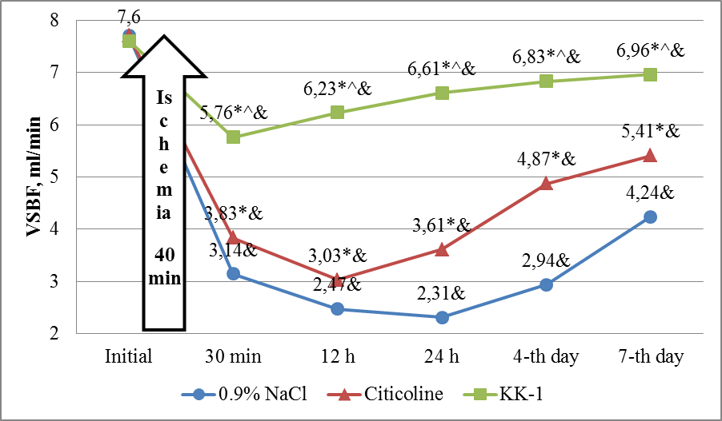
Figure 1. The dynamics of volume speed of blood flow in internal carotid artery on the conditions of using 0.9% NaCl, citicoline and neuropeptide KK-1 against the background of ischemia-reperfusion in rats’ brain, n=21. Note. Here and in figures 2,3 and 4: statistically significant difference (р<0.05) * - to the group of CP, ^ - to the group of citicoline, & - of intergroup dynamics to the initial mark.

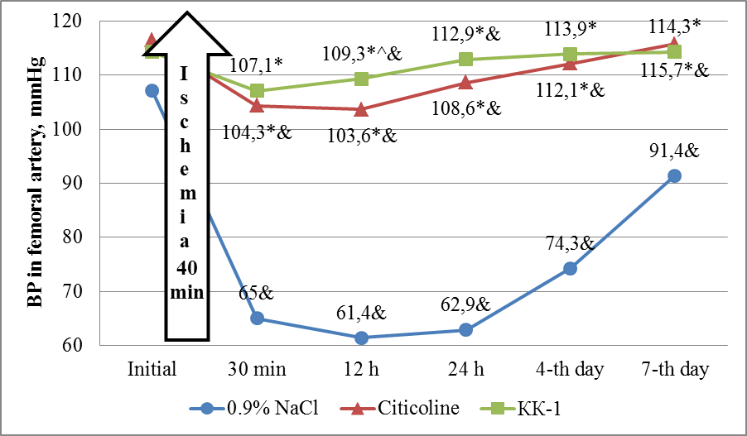
Figure 2. The dynamics of blood pressure in rats’ femoral artery on the conditions of using 0.9% NaCl, citicoline and neuropeptide KK-1 against the background of brain ischemia-reperfusion, n=21.
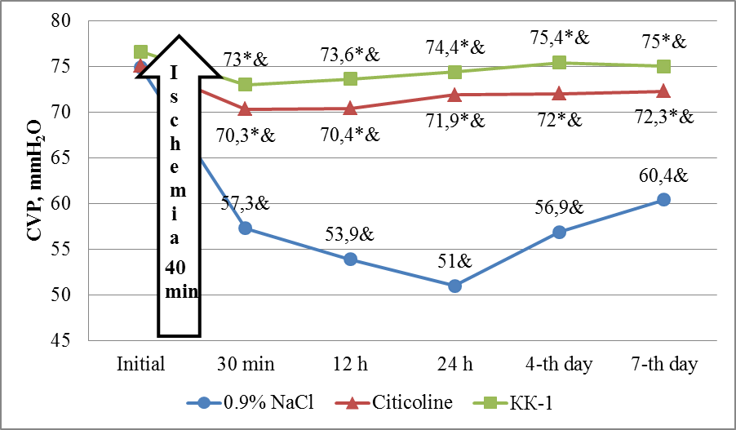
Figure 3. The dynamics of rats’ central venous pressure on the conditions of using 0.9% NaCl, citicoline and neuropeptide KK-1 against the background of brain ischemia-reperfusion, n=21.
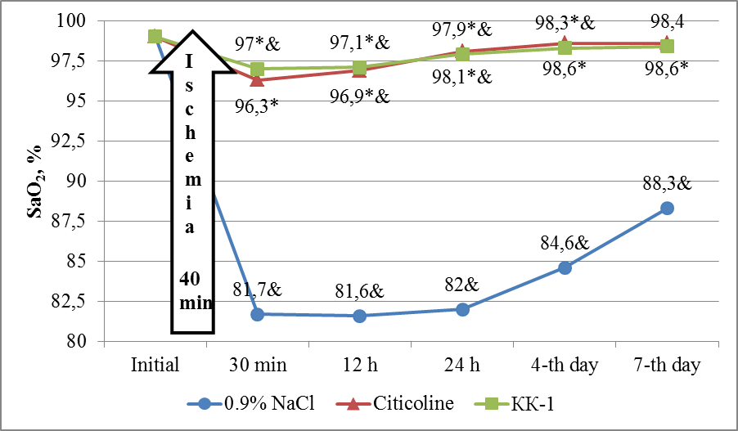
Figure 4. The dynamics of oxygen blood saturation in tongue of rats under influence of 0.9% NaCl, citicoline and neuropeptide KK-1 against the background of brain ischemia-reperfusion, n=21.
Roman D. Deiko, graduate student of pharmacology department of NUPh, master of pharmacy
Sergei Yu. Shtrygol’, Doctor of Medical Sciences, professor, Head of the Department of Pharmacology of NUPh, full member of the ukrainian public organization «The Association of pharmacologists of Ukraine» and IUPHAR
Alexandr A. Kolobov, Doctor of Biological Sciences, Head of the peptide synthesis laboratory of State Research Institute of Highly Pure Biopreparations (Sankt-Petersburg, Russia)
Oleksiy A. Khodakivskyi, Candidate of Medical Sciences, Associate Professor of рharmacology department of National Pirogov Memorial Medical University
Lesia B. Ivantsyk, Candidate of Pharmaceutical Sciences, Assistant Professor of NUPh pharmacology department

National University of Pharmacy of Ministry of Health of Ukraine,
Pushkinska str., 53, м. Kharkiv, 61002
The author, contact person: Roman D. Deiko, graduate student of pharmacology department of NUPh, National University of Pharmacy of Ministry of Health of Ukraine, Pushkinska str., 53, м. Kharkiv, 61002
e-mail: roman.deyko@mail.ru, тел./факс службовий (057) 706-30-69
tel. (099) 962-13-83

