The article is published in Ukrainian in the journal.
The English text is given in the author's version.
UDC: 579.842.11:579.861.
ACTION OF ANTIMICROBIAL AGENTS AND THE LED RADIATION ON A DAILY BIOFILMS OF S.AUREUS AND E.COLI
N.N. Popov, A.M. Korobov, S.G. Malanchuk, N.I. Filimonova,
M.M. Mishyna, Y.M. Mishyn
Evaluating the results to determine the antimicrobial action and the LED radiation on dialy S.aureus and E.coli biofilm under the complex effects using optical emission proved the applicability in the treatment of inflammatory processes incoherent optical radiation of violet spectrum with levofloxacin, which is a photosensitizer and contributes to a decrease in proliferative activity and ability to form biofilms of multiresistant isolates of S.aureus and E.coli and increase their antibiotics resistance.
Keywords: antibiotics, LED radiation, biofilm, S.aureus, E.coli.
Introduction. Over the last years the rate of infections associated with polyresistant microorganisms, especially S.aureus and E.coli, is constantly increasing in the structure of pyoinflammatory nosocomial diseases. Resistance of microorganisms to a range of antimicrobial agents is nowadays one of the topical issues. There have been recorded instances of extraction of polyresistant isolates S.aureus and E.coli as the result of ineffectiveness of antimicrobial agents with administering of more aggressive antibacterial therapy. It has been established that S.aureus and E.coli are often detected on the catheters, joint implants, venflons and they form solid biofilms. Spread of forms of pathogenic bacteria resistant to drugs that tends to decrease efficiency of traditional antimicrobial agents, which are used in in-patient departments, and necessity to elaborate methods of suppression of biofilms formation raise the question concerning new strategies directed to fight against pyoinflammatory diseases and to develop new approaches for creating of schemes of complex therapy which influence specific biochemical and biophysical systems of microorganisms.
The materials and methods of the research. The antibacterial agents such as Amoxiclav, Levofloxacin and Ceftriaxone and the isolates of S.aureus and E.coli received from venflons and drainage constructions and patients with pyoinflammatory processes were the object of the research. Enzyme identification was carried out by means of identification sets MICRO-LA-TEST® (МІКРО-ЛА-ТЕСТ®). Sensitivity of the isolates to antimicrobial agents with different mechanisms of action on a microbial cell was studied by means of microtest system with semiquantitative test recording «ТНКтестГр». Synchronization of periodic culture through selection (Mitchison and Vincent’s technique). Synchronization of periodic cultures of the strains was carried out after establishing of kinetics of growth of the asynchronous culture. The mode of batch fermentation was set in such a way that during exponential growth the cell mass doubled from 2 to 5 times.
Preparation of suspensions of the isolates with specified concentration of the microbial cells was carried out by means of the electronic instrument Densi-La-Meter (PLIVA-Lachema а.s., Czechia) according to the scale McFarland and device instruction; besides test antibacterial agents and growth medium were added.
Measurement of optical density of the biofilm S.aureus and E.coli was made after day incubation at t=37⁰С and on the basis of comparison of optical density of testing and control formed biofilms the conclusions concerning a level of biofilm formation were drawn. The plankton cells extracted from the daily biofilms were inoculated into the plate openings, then suspension growth medium was added and it was thermostated in the wet chamber within 24 hours. After that the level of aggregation of the microbial cells was estimated. Quantification of the level of formation of the biofilm and ability to aggregation of the plankton cells is the value of optical density on the spectrophotometer “Multiskan EX 355” with 540 nm. The result was determined in standard units of optical density (absorbance units) of formation of biofilms by microorganisms.
Emission in vitro was carried out by means of photodiode sources of orange (590 - 600 nm), green (490 -490 nm) and violet (380 - 430 nm) spectra of emission of the photon matrix of Korobov’s device “Barva-Flex” which had a led matrix with superluminescent diodes and a power supply unit. For statistical analysis of the results Exel for PC and Biostat were used.
The results of the research and its consideration. On the basis of the results concerning estimation of action of antimicrobial agents and photodiode emission on the daily biofilms of S.aureus and E.coli it has been established (Figure 1) that under complex influence with use of optical emission of orange the spectrum and β –lactam antimicrobial agents, the biofilm density was 1.5 times higher than control values and it amounted to: on application of Amoxiclav in the isolates of S.aureus – 3.469±0.06 absorbance units and 2.35±0.08 absorbance units; by 1.2 times in isolates of E.coli – 1.764±0.09 absorbance units and 1.469±0.05 absorbance units; on application of Ceftriaxone – in the isolates of S. aureus: 3.474±0.03 absorbance units and 2.24±0.06 absorbance units and E.coli – 1.638±0.09 absorbance units and 1.475±0.05 absorbance units. On complex application of the medical agent from fluroquinolone group that is Levofloxacin and photodiode emission of the orange spectrum decrease of density of the daily biofilm S.aureus by 42.8 times (0.054±0.09 absorbance units and 2.31±0.07 absorbance units) and E.coli – by 18.9 times (0.0.078±0.08 absorbance units and 1.472±0.06 absorbance units consequently) in comparison with control was observed.
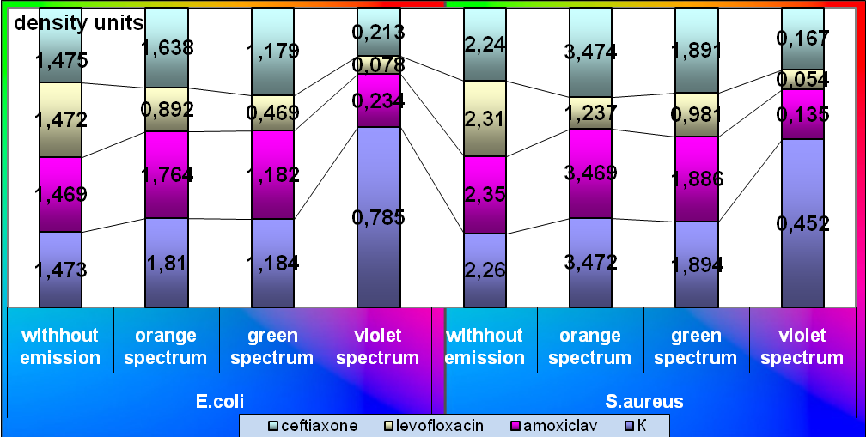
Figure 1. Action of the test medical agents and optical emission on daily biofilms of the polyresistant isolates of S.aureus and E.coli.
In consequence of the research concerning estimation of influence of low intensity incoherent emission of the green spectrum together with β-lactam antimicrobial agents on daily biofilms of the polyresistant strains, the tendency to suppression of density of the biofilm of the isolates of S.aureus (Amoxiclav – 1.886±0.09 absorbance units and 2.35±0.08 absorbance units; Ceftriaxone – 1.891±0.05 absorbance units and 2.24±0.06 absorbance units), as well as E.coli (Amoxiclav – 1.182±0.09 absorbance units та 1.469±0.05 absorbance units; Ceftriaxone – 1.179±0.04 absorbance units та 1.475±0.05 absorbance units) in comparison with control is observed. And if Levofloxacin is applied in combination with photodiode emission of the green spectrum, destruction of daily biofilms of the polyresistant isolates of S.aureus by 2.4 times (0.981±0.02 absorbance units and 2.31±0.07 absorbance units) and E.coli by 3.1 times (0.469±0.08 absorbance units and 1.472±0.06 absorbance units consequently) in comparison with control is observed.
Application of the antimicrobial agents and photodiode emission of the violet spectrum resulted in decrease of density of daily biofilms of S.aureus: by 17.4 times when Amoxiclav was used (0.135±0.08 absorbance units and 2.35±0.08 absorbance units); by 13.4 times on application of Ceftriaxone (0.167±0.07 absorbance units and 2.24±0.06 absorbance units) and by 42.8 times in combination with Levofloxacin (0.054±0.009 absorbance units and 2.31±0.07 absorbance units consequently). The same results were obtained in study of influence of the antimicrobial agents and photodiode emission of the violet spectrum on daily biofilms of the polyresistant isolates of E.coli: by 6.3 times if Amoxiclav was used (0.234±0.03 absorbance units and 1.469±0.05 absorbance units), by 7 times on application of Ceftriaxone (0.213±0.06 absorbance units and 1.475±0.05 absorbance units consequently) and by 18.9 times in combination with Levofloxacin (0.078±0.009 absorbance units and 1.472±0.06 absorbance units consequently) in comparison with control.
On determining of the ability of daily biofilms of the polyresistant strains of S.aureus and E.coli after action of photodiode emission and β-lactam antimicrobial agents to produce plankton cells it has been established that in action of the orange spectrum increase of proliferative activity by isolates of S.aureus up to 2.1 times in comparison with control is observed (on application of Amoxiclav – 1.732±0.09 absorbance units and 0.829±0.08 absorbance units and when Ceftriaxone is used – 1.741±0.06 absorbance units and 0.832±0.09 absorbance units consequently) as well as the tendency to proliferation of plankton cells of polyresistant strains of E.coli (on application of Amoxiclav – 0.829±0.02 absorbance units and 0.707±0.05 absorbance units and when Ceftriaxone is used – 0.821±0.04 absorbance units and 0.705±0.09 absorbance units consequently) (Figure 2).
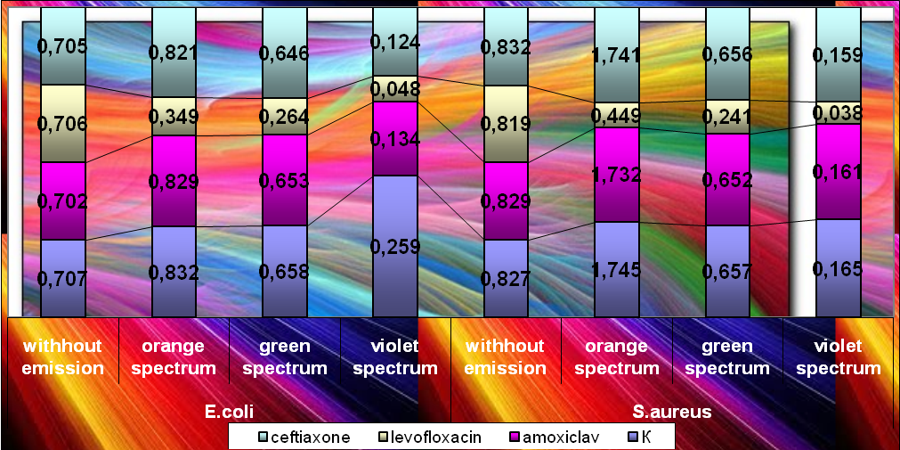
Figure 2. Production of the plankton cells by daily biofilms of the polyresistant isolates of S.aureus and E.coli after action of the test medical agents and optical emission.
When the medical agent from fluroquinolone group that is Levofloxacin is used in combination with photodiode emission of the orange spectrum, suppression of production of plankton cells of S.aureus by 1.8 times – 0.449±0.08 absorbance units and 0.819±0.04 absorbance units as well as E.coli by 2 times – 0.349±0.03 absorbance units and 0.706±0.07 absorbance units consequently is observed. If photodiode emission of the violet spectrum and Levofloxacin are used, suppression of production of the plankton cells by daily biofilms of E.coli by 14.7 times (0.048±0.06 absorbance units and 0.706±0.07 absorbance units consequently) and S.aureus – by 21.6 times (0.038±0.02 absorbance units and absorbance units 0.819±0.04 absorbance units) in comparison with control is observed.
The same results were recorded on determining of the ability of the plankton cells radiated by daily biofilms with inoculated antimicrobial agents: the lowest density of the secondary biofilm was recorded on application of optical emission of the violet spectrum in combination with Levofloxacin: density of the secondary biofilm of S.aureus was decreased by 52.4 times (0.067±0.04 absorbance units and 3.512±0.08 absorbance units) and the one of E.coli was decreased by 39.3 times (0.086±0.05 absorbance units and 3.382±0.09 absorbance units consequently ) in comparison with control (Figure 3).
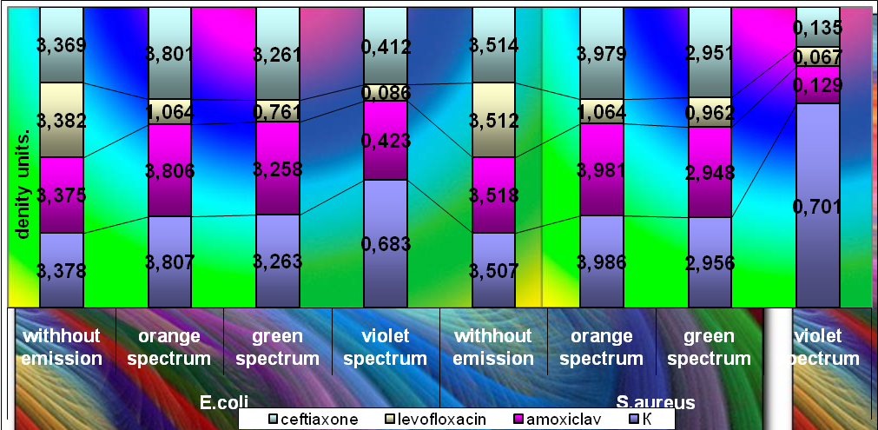
Figure 3. Formation of the secondary biofilms by the plankton cells of S.aureus and E.coli after action of the test medical agents and optical emission on daily biofilm of the polyresistant isolates.
Therefore, the research has made it possible to substantiate the possibility of use of low intensity incoherent optical emission of the violet spectrum with Levofloxacin, which is a photosensitizer and thus contributes to suppression of proliferative activity and the ability to form biofilms of the polyresistant isolates S.aureus and E.coli to increase their antibiotic susceptibility, in complex therapy of pyoinflammatory processes. In this way, the most important phenotypic feature of the isolates, that under current conditions provides survivability of bacteria in in-patient department as well in the human organism in case of infection process, is a biofilm. The biofilm of microorganisms is characterized by increased resistance to antibiotics, antiseptic drugs and disinfectants. This fact causes complications in treatment and increases the rate of nosocomial infections. In this regard, the use of photodiode emission of the violet spectrum with the antimicrobial medical agent such as Levofloxacin contributes to destruction or recently formed daily biofilms of the isolates and prevents formation of new biofilms and antibiotic-resistant strains consequently.

REFERENCES

- Іваниця В.О., Галкін М.Б. // Мікробіол. і біотехнол. – 2011. – №2. – С. 8-22.
- Коробов А.М., Коробов В.А., Лесная Т.А. Фототерапевтические аппараты Коробова серии «Барва». – Х.: ИПП «Контраст», 2008. – 176 с.
- Курочкина А.Ю., Плавский В.Ю., Юдина Н.А. Классификации фотосенсибилизаторов антимикробной фотодинамической терапии / Белорусская медицинская академия последипломного образования, Институт физики НАН Беларуси [Електронний ресурс]: режим доступу до журналу http://www.bsmu.by.
- Лапач С.Н., Чубенко А.В., Бабич П.Н. Статистические методы в медико-биологических исследованиях с использованием Excel. – К.: МОРИОН, 2000. – 320 с.
- Методические указания по применению унифицированных микробиологических (бактериологических) методов исследования в клинико-диагностических лабораториях / Прилож. I к Приказу Министерства здравоохранения СССР №535 от 22 апреля 1985 г. – 123 с.
- Мирошниченко И.И., Зачиняев Я.В., Зачиняева А.В. // Иммунопатол., аллергол., инфектол. – 2009. – №1. – С. 27.
- Осипов В.П., Лукьянова Е.М., Антипкин Ю.Г. и др. Методика статистической обработки медицинской информации в научных исследованиях. – К.: Планета людей, 2002. – 200 с.
- Пат. на корисну модель 47944 Україна, МПК G 09 B 23/00. Спосіб відтворення біоплівок мікроорганізмів in vitro / А.Я.Циганенко, М.М.Мішина, Р.А. Курбанов (UA); Харк. націон. мед. ун-т. – № u200910353; Заявл.: 12.10.2009. Опубл.: 25.02.2010. – Бюл. №4.
- Фадеев С.Б., Чевычалова Е.В., Сгибнев А.В., Бадьянова Е.В. Видовое разнообразие возбудителей хирургической инфекции мягких тканей, вызванной микробными ассоциациями // Сб. тр. V науч.-практ. конф. врачей Приволжско-Уральского Военного округа. – Оренбург, 2004. – С. 326-327.
- Фадеев С.Б., Тарасенко В.С., Стадников Б.А., Казеннов А.Н. Изменение видового состава возбудителей хирургической инфекции мягких тканей // Тезисы 11-й науч. конф. Европейского общества химиотерапии инфекционных заболеваний и 6-й Рос. конф. «Современные проблемы антибактериальной терапии». – М., 2004. – С. 30.
- Brinkmann V., Laube Br., Abed U. et al. // J. of Visualized Experiments. – 2010. – Vol. 36. – P. 1724.
- Reśliński A., Mikucka А., Szmytkowski J. // Pol. J. Microbiol. – 2009. – №58 (4). – P. 367-369.
- Stewart P.S. Antibiotic tolerance in biofilms and its role in persistent infections / In: 11-th Intern. congr. on infectious dis. Cancun, Mexico. – 2004. Abstr. №56.002.
- Weigel L.M. // Antimicrob. Agents Chemother. – 2007. – Vol. 51, №1. – P. 231-238.
- Wolcott R.D. // J. Wound Care. – 2010. – Vol. 19, №2. – P. 45-50, 52-53.

