The article is published in Ukrainian in the journal.
The English text is given in the author's version.

UDC 615:519.076
IMPLEMENTATION OF IMITATION MODELLING FOR QUANTATIVE RISK ASSESSMENT IN CLINICAL TRIAL DATA COLLECTION
K.O. Zupanets, K.L. Ratushna, V.Ye. Dobrova, O.O. Andreeva
National University of Pharmacy
Key words: clinical trial, risk management, key risk indicator, data quality, CRF
Appropriate data collection is an essential aspect of clinical trial (CT) quality and includes accurate and precise data entered into case report form (CRF) The paper presents results of risk assessment and modelling for data collection process on trial site. In research 292 CRF were analysed and CRF corrections documentation for 12 studies carried out in Clinical and Diagnostic Centre of National University of Pharmacy (CDC NPhaU). In order to evaluate the rate of errors made in CRF we proposed a key risk indicator – error coefficient () with specific intervals of values: optimal (0 – 3); threatening (3,1 – 5); critical (more than 5). The model of error coefficient changes was created by Monte-Carlo method and probability of critical values of error coefficient was 0,026. The economic consequences for these cases were predicted by modelling on the base of expert estimates regarding CT project time and required costs. Probability of maximal project time increasing to 4 days was 0,019, probability of maximal additional costs varies to 3% of the budget was 0,02. Results obtained is the evidenced of high quality of data collection process in CDC NPhaU. Proposed methodology may be recommended for sponsors for risk-based monitoring implementation, for trial sites preparing to monitoring visits, audits or inspections, for regulatory bodies for planning inspections of trial sites.
Introduction
High speed development of clinical trials (CT) in Ukraine and on the globe, growth of its complexity and number of patients involved leads to competition strengthening and increasing of requirements to CT quality. With respect to accurate control and requirements to time of CT carrying out and available budget, the task of clinical trial quality assurance becomes more complicate, and this demands implementation and integration into CT system quality management and risk management approaches [13].
Quality risk management is one of modern approaches consistent with quality management concept, which implementation is under numerous discussions among scientists and specialists in clinical research of drugs [10, 12, 14, 15]. Application of quality risk management approaches on the stage of clinical development of drugs demands concentration on the main elements of clinical trial quality – rights, safety and well-being of trial subject as well as completeness of clinical data [5, 7].
Clinical data obtained during study is an important element of CT quality. It is the basis for reliable CT results which together with results of preclinical studies form the evidence-based foundation of effectiveness and safety and influence significantly the success of clinical trial project. Considering that, aspects of clinical data management become more important allowing to obtain during CT quality data and to coordinate data processes in effective way.
Methods and regulations of risk-based management allow predicting, identifying and eliminating risks, avoiding serious problems. It improves data management processes quality and, as a result, quality and validity of study results [14]. Application of quality risk management methodology according to each process of data management system in CT is an important part of successful quality management implementation and goal achievement – validate results regarding effectiveness and safety of a drug.
One of important stages, that basically define the quality of trial results, is data collection during study [1, 2]. This stage includes data obtaining by means of measuring changes in patient / health volunteer body after drug administering and registering these changes by special tool – case report form (CRF). One of the most important elements characterized accuracy of CRF data that lies in consistency and conformity with source data [11]. Also important is completeness of data, data accurateness in CRF, compliance with established requirements and content of corrections log. Correctness and completeness of source data registered in CRF, compliance with GCP requirements, study protocol and standard operational procedures is an important part of clinical trial results quality assurance [5]. Significance of this characteristics make it possible to say about high importance of its assessment during internal quality control procedures carrying out by trial site as well as external quality procedures initiated by regulatory bodies during inspection or by sponsor during monitoring procedures.
The most prevalent and unavoidable risk is errors in CRF that should be corrected during source data verification. Non-compliance and risks during data collection and its registration in CRF lead to bias, influencing all further processes of clinical data management system that complicates risk identification and results in poor data quality. Considering interrelation of key characteristics of clinical data management process – quality, time and resources, problems in data registering to CRF impact timeliness of CT and can lead to increasing total budget.
Thus, the aim of study was quantitative assessment of risk of errors in CRF at trial site and predicting its potential consequences by imitation modelling.
The object of study was the process of CRF completion which is one of the most important processes of data processing and may be related to numerous risks influencing clinical trial data quality.
Materials and methods
We have researched 292 CRF of 12 bioequivalence studies that were carried out in Clinical and Diagnostic Centre of National University of Pharmacy (CDC NPhaU) in the period from 2003 to 2013. All CRF were practically identical structure. Number of pages varied from 27 to 45.
According to the model of data quality risk management that was proposed and discussed in previous researches, one of its stages is risk assessment [3, 4]. Risk assessment includes determining the probability of risk, impact of its effects on data quality, prioritization and modelling of risks [8, 10]. Implementation of imitation modelling enables assessing objectively risks and their effects using statistical methods and retrospective analysis of data, subjective and expert estimates, allows risk forecasting and contributes to better and more sound decision-making [17]. In this research the Monte-Carlo method was used, which is based on random processes modelling and statistical estimating of values of interest that are associated with uncertainty [9]. Also expert survey method and statistical methods were used.
Statistical calculations and imitation model were generated in Statistica (StatSoft Inc.), Microsoft Excel 2010 (Microsoft Inc.), @Risk 6 (Palisade Corporation).
Results and its discussion
At the first stage of research after analysis of CRF sructure there was determined that each CRF includes the following data categories: volunteer identification data, demografic data, anthropometric data, medical hystory, inclusion/exclusion criteria eligibility, treatment, time and data of clinical procedures according to study protocol, instrumental examination, physical examination, adverse reaction and adverse events.
According to number of volunteers total number of data categories for each trial varies from 240 to 260.
Further stage was to research the log of CRF errors and corrections which is one of main documents of clinical trial according to Order of Ministry of Health №690 since 23.09.2009 [6]. In the process of research there was identified the total number of CRF errors was 84. Among 292 CRF al least 66 were with one or more corrections.
After stratification of errors by data categories there was identified one third of all corrections (31%) were related to time and data of clinical procedures. Large part of errors (19%) was related to instrumental examination and the same part were related to physical examination (Fig. 1).
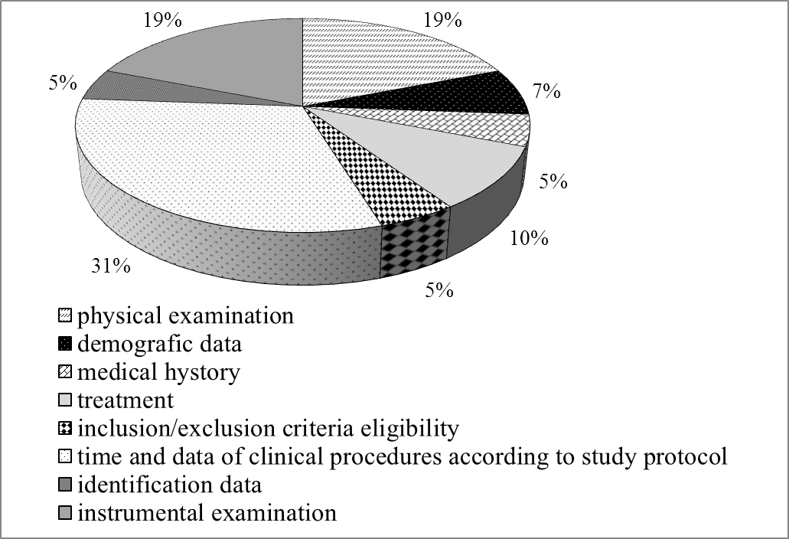
Figure 1. Stratification of CRF errors by data categories
The less part of corrections was related to volunteer identification data, medical history and inclusion/exclusion criteria eligibility (5% in each category). Anthropometrical data, adverse reactions/adverse events categories were without errors.
The next stage of research was to design a quantitative indicator for evaluation of CRF error and corrections rate.
In order to assess risks in clinical data management there was proposed to use specific key risk indicators (KRIs) regarding to data quality, measuring of which enables objectively assess and control quality of data management processes in clinical trial. Overall KRIs system characterizes each of cornerstone data quality aspect in clinical trial and allows to obtain quantitative information about its influence on trial results.
For interpretation of KRIs values it is necessary to determine and establish intervals specific for each indicator which represent the quality of each process: optimal, threatening and critical. If KRIs is in critical intervals there are serious problems in data management process that demand from stakeholders application of corrective actions and analysis of causes of non-compliance. If the KRI value is in threatening interval the potential problem and risk situation is in data management process and may cause a negative effect on data quality. This situation also demands implementation of appropriate activities including preventive actions, processes diagnostics, determining potential non-compliance and its causes, data quality risks minimization.
According to the mentioned above, in order to control the process of data registration in CRF we proposed to use the error coefficient () that provides the quantative assessment of CRF errors rate. This KRI characterizes CRF completion quality and may be used to monitor the number of errors generated during data transfering from source documentation to CRF. Below there is outlined the formula for calculation of the error coefficient which was proposed to calculate by normalizing the total number of errors by number of data categories.
(1)
where - total number of errors; - total number of data categories.
There was proposed to establish the specific intervals for the CRF errors coefficient: optimal (0 – 3); threatening (3,1 – 5); critical (more then 5). Values 3 and 5 are thresholds of the CRF errors coefficient and are associated with the appropriate actions.
Simple calculation of the CRF error coefficient during trial conducting provides the capacity to assess in real time quality of CRF completion process, reacting urgently on the process changing. However, episodically measuring of KRIs may be not enough for risk assessment because of impossibility to produce the entire situation about risks in CT especially when planning a study. Thus, we proposed to use for risks assessment in clinical trial data management system Monte-Carlo imitation modeling that enables to predict studied risks and its influence on research project success.
In order to construct the model for the variables та which are associated with uncertainty we determined distribution functions and its parameters using the data obtained in result of CRF analysis.
Considering the total number of CRF corrections in each study we constructed a histogram represented the frequency distribution of errors number (Figure 2). This histogram represents the distribution parameters of error rates that enable to forecast variable. As presented in figure 2, frequency distribution of errors number is aproximate to lognormal (µ=6; σ=2,7).
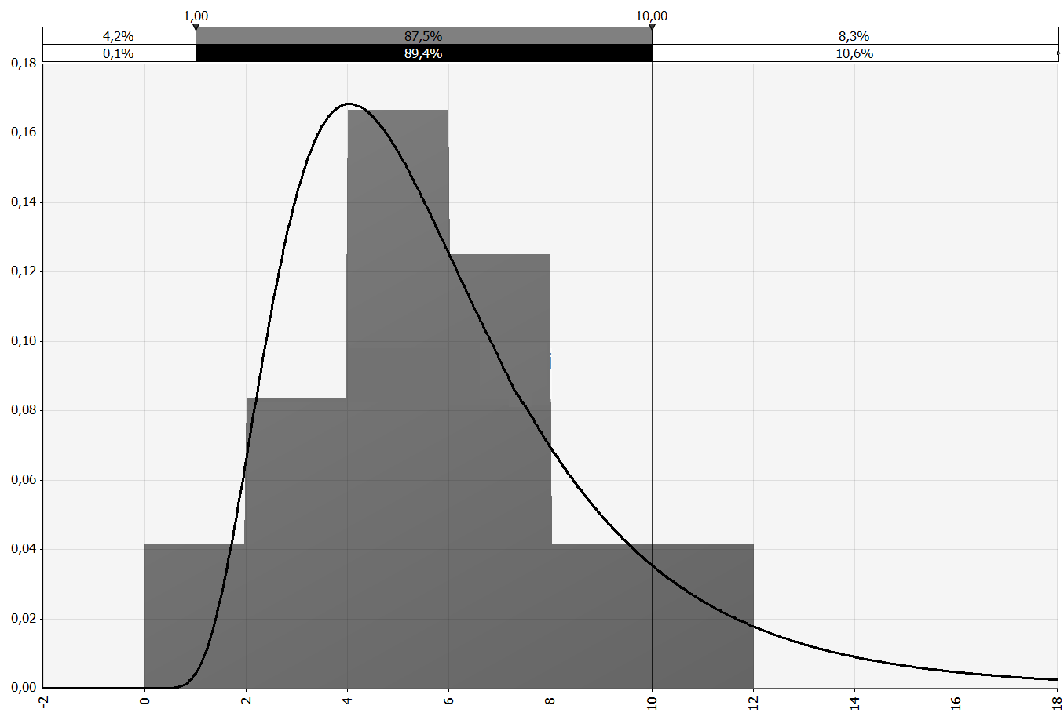
Figure 2. Hystogram of CRF errors total number ()
Total number of data categories in clinical trial is conformed to discontinuous distribution (minimal value is 240, maximal value is 260).
To assure appropriate preciseness of modeling the number of iterations was 100 [9].
According to constructed model of CRF error coefficient, 76,5% of model values were in optimal interval (0 – 3), that means the value of error coefficient in the next clinical trial of CDC NPhaU will be target with probability 0,765.
In the threatening interval (3 – 5) there were 20,9% of error coefficient values. Thus, with 0,209 probabilities error rate will be less then critical but significantly high, that is potential threat for effectiveness and quality of CRF completion process. In this situation, authorized person in quality should apply appropriate preventive actions targeted on identification and removing the causes of CRF error rate 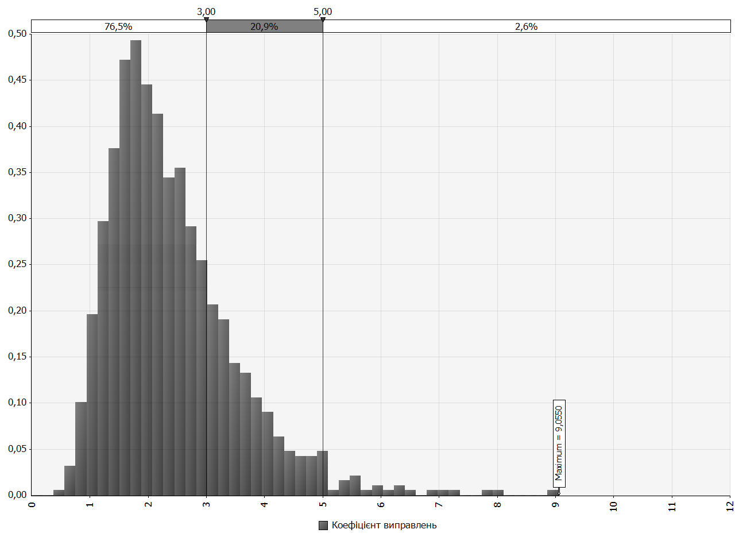 Figure 3. Monte-Carlo simulation of the CRF error coefficient
increasing, for example, reviewing of SOP, regulated CRF completion, analysis of
personal work, overall process of CRF completion. If the error coefficient is threatening, sponsor also may apply following actions: perform comparative analysis of error coefficient across trial sites, visit trial site, call trial site in order to solve potential problem and issues have arisen.
It was identified, that only 2,6% values of error coefficient exceed threshold of threatening interval and are critical, in other words, the probability error coefficient will be critical is 0,026. This situation demands urgent reaction, because of negative influence on quality of data operating processes. If the error coefficient increases value 5, trial site should implement urgent corrective actions, for example, apply more extent of control by additional verification of CRF data. Sponsor may initiate monitor visit on trial site, 100% source data verification, reviewing SOPs and control personal knowledge of SOPs, additional training regarding CRF completion.
Based on constructed model, we evaluated potential cost consequences of situations if error coefficient increases acceptable threshold (>5), probability of which is 0,026. The expert were interviewed to obtain the data demand on CRF error corrections and additional cost caused by initiating unexpected work related to advanced control and error corrections. To experts’ view, each 0,5 points increasing of error coefficient results in increasing of trial time on 0,5%-2%. Considering these data, we constructed models represented the probabilities of increasing in time and cost of clinical trial (figure 4, 5).
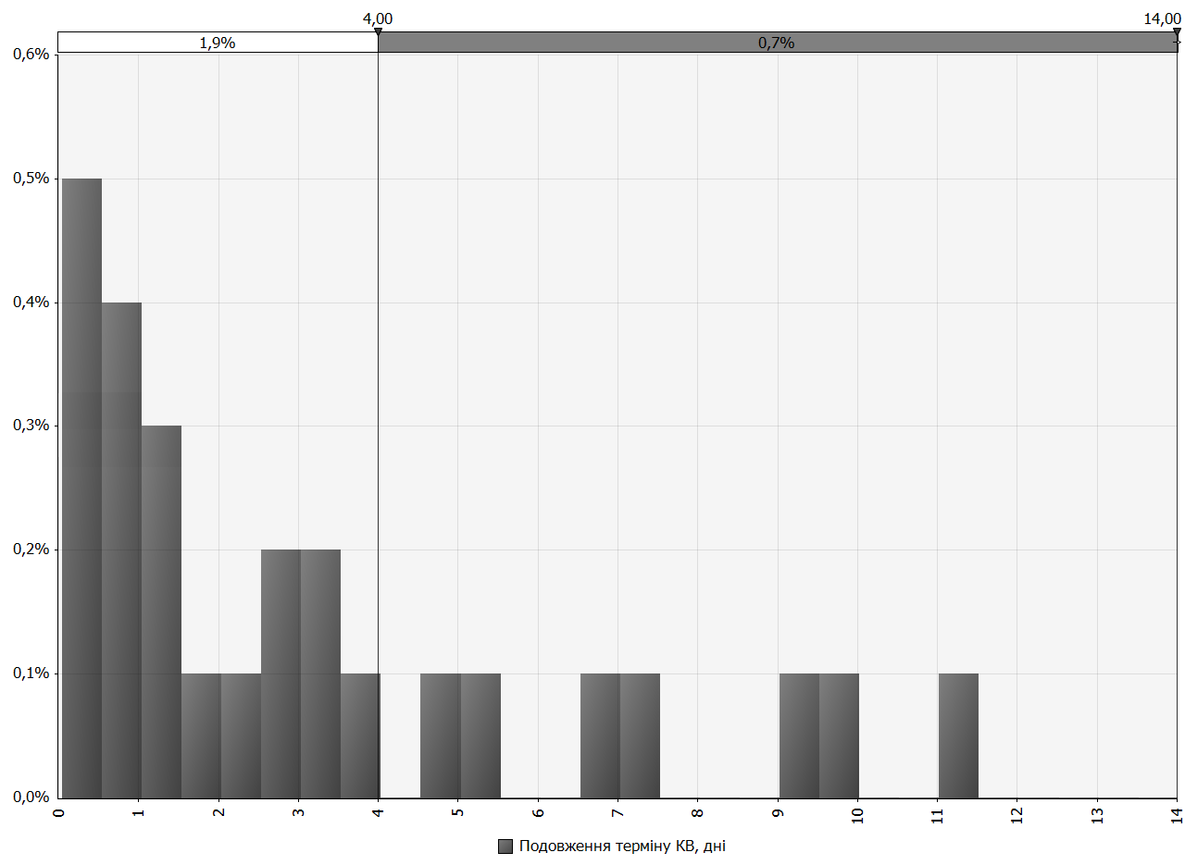
Figure 4. Simulation of increasing of clinical trial project time (>5)
According to the modeling results represented in fig. 4, in 2,6% total cases in which error coefficient increases 5, probability of trial time increasing in 1 day is 0,009, from 1 to 2 days is 0,004, from 2 to 3 days – 0,003, from 3 to 4 days – 0,003, more than 4 days – 0,007. To our point of view, risk of lengthening trial more than to 4 days is negligible because of small values.
Probability of 1% additional trial cost is 0,009, from 1% to 2% - 0,005, from 2% to 3% - 0,006, more than 3% of additional cost is characterized by 0,006 probabilities. To our point of view, risk of additional trial cost more than 3% is negligible because of small values.
Considering results of modeling consequences of non-compliance with requirements to CRF completion for project time and budget we can resume that probability of maximal project time increasing to 4 days was 0,019, probability of maximal additional costs varies to 3% of the budget was 0,02.
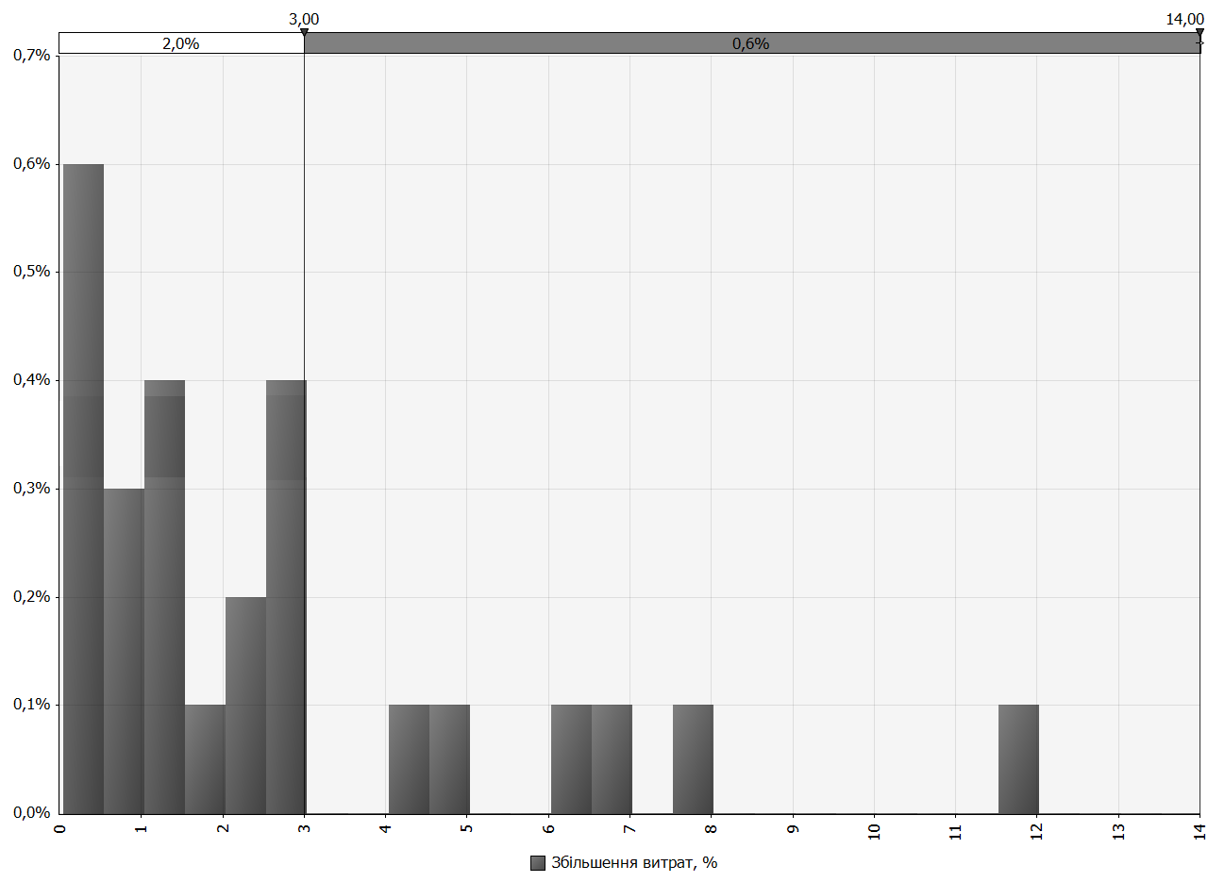
Figure 5. Simulation of increasing of trial cost (>5)
CONCLUSIONS
According to principles of quality management and risk management, we researched process of CRF completion which is one of the most important elements of clinical trial data management system, an essential part of clinical trial quality system and the critically important process for data quality assurance. In order to quantitatively evaluate, control and simulation of risk, associate with this process, we designed KRI - error coefficient which characterizes quality of CRF completion. Based on data, obtained in an analysis of CRF on CDC NPhaU we performed simulation of error coefficient changes. On the basis of constructed model, there were analyzed potential financial consequences of problems related to errors in CRF data and its impact on time requirements of trial processes conducting.
Based on research results we can resume that probability of error coefficient increasing the critical threshold is 2,6%. We consider this value is small and lies in limits of tolerable error (5%). It is the evidence of high level quality of CRF completion process in CDC NPhaU. Using results of this research, additional training of personal was initiated, SOPs reviewing and its improvement. Furthermore, there were developed SOPs design methodical recommendations and the plan of risks assessment actions.
Evaluation of economic consequences of risks for clinical trial timeliness and cost make it possible to say they are acceptable. Probability of maximal project time increasing to 4 days was 0,019, probability of maximal additional costs varies to 3% of the budget was 0,02. KRI error coefficient proposed in this research should be included to the single KRIs system that allows to measure risks for each process critical for data quality and is the essential tool for many types of trial site functioning control.
Monitoring trial sites using KRIs system sponsor may evaluate site’s risks in real time providing prompt reaction and applying of appropriate preventive actions. This approach provides focusing on the most significant and likely risks related to processes critically important for data quality. Moreover, considering KRIs enables sponsor to develop monitoring plan targeted on the most important risks and established frequency, extent and content of monitoring activities according to results of risk assessment.
Using specific KRIs during internal audits, or preparing for audits or inspection, provides continuous improvement of trial site’s processes due to the feedback.
The procedures of CRF error coefficient calculation and simulation proposed in the study may be recommended for inspection planning and conducting.
ЛІТЕРАТУРА
- Доброва В.Є., Зупанець І.А. // Управління, економіка та забезпечення якості в фармації. – 2011. – №. 3(17). – С. 17-22.
- Доброва В.Є., Зупанець І.А., Мороз А. М. та ін. Методологічні принципи організації системи управління даними у клінічних випробуваннях : Метод. рекоменд. – Х.: ФОП Петров В.В., 2012. – 36 с.
- Доброва В.Є., Зупанець К.О., Ратушна К.Л. та ін. // Управління, економіка та забезпечення якості в фармації. – 2013. – №5(31). – С. 16-23
- Доброва В.Є., Зупанець К.О., Ратушна К.Л. // Клінічна фармація. – 2014. – №1(18). – С. 4-10.
- Клинические испытания лекарств / Под ред. В.И. Мальцева, Т.И. Ефимцевой, Ю.Б. Белоусова и др. – 2-е изд., перераб. и доп. – К.: МОРИОН, 2006. – 456 с.
- Наказ Міністерства охорони здоров’я України №690 від 23.09.2009 «Порядок проведення клінічних випробувань лікарських засобів та експертизи матеріалів клінічних випробувань. – Режим доступа: http://zakon.rada.gov.ua/cgi-bin/laws/main.cgi?nreg=z1010-09.
- Настанова СТ-Н МОЗУ 42-7.0:2008 Лікарські засоби. Належна клінічна практика. – Київ, 2009. – 67 с.
- Настанова СТ-Н МОЗУ 42-4.2:2011 Лікарські засоби. Управління ризиками для якості. – Київ, 2011. – 26 с.
- Паньгина Н.Н., Паньгин А.А. // Компьютерные инструменты в образовании. – 2002.– №5.– С.30-43.
- Alemayehu D., Alvir J., Chappell P. B. et al. // Applied Clinical Trials. – 2012. – Vol.5. – P. 15-16.
- Assuring Data Quality and Validity in Clinical Trials for Regulatory Decision Making; Workshop Report / Davis J.R., Nolan V.P., Woodcock J., Estabrook R.W. – Roundtable on Research and Development of Drugs, Biologics, and Medical Devices, Institute of Medicine. – Режим доступу: http://www.nap.edu/catalog/9623.html
- Brosteanu O., Houben P., Ihrig K. et al // Clinical Trials. – 2009. – Vol. 6. – P. 585-596.
- Djali S., Janssens S., Yper S. Drug Information Journal. – 2010. – Vol. 44. – P. 359-373.
- European Medicine Agency. Reflection paper on risk based management in clinical trials. – Режим доступа: http://www.ema.europa.eu/docs/en_GB/document_library/Scientific_guideline/2011/08/WC500110059.pdf
- Gregg H. Claycamp // Drug Information Journal. – 2007. – Vol. 41. – P. 353-367.
- MRC/DH/MHRA joint project; Risk-adapted Approaches to the Management of Clinical Trials of Investigational Medicinal Режим доступа: http://www.mhra.gov.uk/Howweregulate/Medicines/Licensingofmedicines/Clinicaltrials/index.html
- Robinson M., Cook S. Clinical Trial Risk Management. – Boca Raton: Francis and Taylor, 2006. – 211 p.
- Rosenberg M.J. // Therapeutic Innovation and Regulatory Science. – №48(4). – P. 428-435.
- Sax A., Keegan M., White D. et al. // Journal for Clinical Studies. – 2012. – Vol.4(5). – P. 26-33.

