The article is published in Ukrainian in the journal.
The English text is given in the author's version.

UDC 615.252:616.379-008.64:519.866
Mathematical modeling as a method of choice pharmacoeconomic justified schemes of combined therapy of type 2 diabetes

Ivko T.I., assistant of pharmacy department,
Germanyuk T.A., doctor of medicine, professor of pharmacy department,
National Pirogov Memorial Medical University, Vinnytsya, Ukraine

Key words: diabetes mellitus; cost-effectiveness analysis; cost-utility analysis; mathematical modeling
The pharmacoeconomic study has been conducted with the purpose of scientific substantiation of the regimens of combined therapy of type 2 diabetes mellitus (DM). The research subjects were 1792 inpatient medical histories of the patients with type 2 DM. These patients were treated at the Vinnytsia regional endocrinology clinic, endocrinology departments of the Khmelnytsky and Ternopol regional hospitals in 2011-2013. The following methods were used in the research: frequency analysis, ATC/DDD-analysis, cost-effectiveness analysis, cost-utility analysis, sensitivity analysis, mathematical modeling. As a result of the frequency analysis conducted it has been found that the following regimens of pharmacotherapy are the most frequently used: metformin + glimepiride applied in 45% of cases, gliclazide + metformin – in 14.5% of cases, metformin + glibenclamide – in 6.1% of cases. ATC/DDD-analysis has shown that the cost of DDD of metformin + glimepiride is ranged from 2.70 (Dianormet t.850 mg No.30 + Diapiryd 3 mg t.№30) tо 8.88 UAH (Siofor 500 mg t. No.60 + Amaril 2 mg t. No.30), metformin + gliclazide – from 3.29 (Diaformin 850 mg t. No.60 + Diaglizyd MR 30 mg t. No.60) to 9.43 UAH (Siofor 500 mg t. No.60 + Diabeton MR 60 mg t. No.30), metformin + glibenclamide – from 1.98 (Diaformin 850 mg t. No.60 + Glibenclamide 5 mg t. No.100) to 6.20 UAH (Siofor 500 mg t. No.60 + Maninil 3,5 mg t. No.120). The results obtained indicate the cost-effective and cost-utility advantages of the regimen of the combined therapy metformin + glibenclamide. The sensitivity analysis has shown stability of the pharmacoeconomic study results. The mathematical model of the "Decision Tree" that graphically shows the results of pharmacoeconomic studies has been constructed.

Topicality. Type 2 diabetes mellitus (T2DM) is a medical and social problem. More than 300 million people suffer from DM around the world in our time. Yet 350 million have high risk of DM. The International diabetes federation predicts that by 2030 nearly half a billion people will lives with DM around the world [2]. DM is 31.88% in the structure of endocrine diseases and ranks the second in Ukraine. Increase of prevalence indicator of DM observed in Ukraine by 26% over the last 5 years. The number of patients increases due by T2DM.

This disease gets the status non-infectious epidemic. T2DM needs effective and economically justified therapy in the limited financing of health care [2]. So, the choice of rational pharmacotherapy should take into account the results of pharmacoeconomic researches.
The purpose: scientific justification for the choice of schemes of combined therapy of type 2 diabetes mellitus
The object of the study: the pharmacotherapy of T2DM
The research materials: 1792 inpatient’s medical histories of the patients with type 2 DM. These patients were treated at the Vinnytsya regional endocrinology clinic, endocrinological department of Khmelnytsky hospital and Ternopol regional hospital in 2011-2013.
Research methods:

1. frequency analysis;
2. ATC/DDD-analysis;

3. cost-effectiveness analysis;

4. cost-utility analysis;

5. sensitivity analysis;
6. mathematical modeling.
Research objectives:
1) carrying out retrospective analysis of medical histories and treatment sheets of T2DM inpatients;
2) perform frequency analysis of the consumed treatment regimens;

3) analyze the patients included in the scientific study, according to certain parameters: age, gender, body mass index (BMI), fasting plasma glucose (FPG) on admission to hospital, disease duration, period of stay in hospital;
4) research the treatment regimens by cost-effectiveness analysis;
5) research the treatment regimens by cost-utility analysis;

6) carrying out the mathematical modeling.

Results of research.

Frequency analysis of all (1792) medical histories and treatment sheets of T2DM patients who were included in this study allows to select the most frequently used drug regimens. These patients were treated at the Vinnytsya regional endocrinology clinic, endocrinological department of the Khmelnytsky hospital and Ternopol regional hospital in 2011-2013.

As a result of the spent frequency analysis it has been established that following 25 treatment regimens were used for the treatment of T2DM: metformin + glimepiride applied in 45% of cases, metformin monotherapy – in 16.2% of cases, gliclazide + metformin – 14.5%, metformin + glibenclamide – 6.1%, glimepiride monotherapy – 5.1%, monotherapy gliclazide – 3.9%, metformin+sytagliptin – 1.7% metformin+saxagliptin – 1.3%, glibenclamide – 1 %, metformin + glimepiride + sytagliptyn – 0.7%, treatment regimens metformin + pioglitazone, metformin + glimepiride + metformin + pioglitazone and glimepiride + saxagliptyn were used in 0.6% of cases each, glycvidon – in 0.4% of cases, glycvidon + metformin, metformin + repaglinide, repaglinide, gliclazide + saxsagliptyn and herbal collection were used in 0.3% of cases each, combination saxsagliptyn, metformin + gliclazide + saxagliptyn were used in 0.2% of cases each, scheme sytagliptyn, metformin + liraglutyd, glimepiride + pioglitazone and glimepiride + saxagliptyn were used in 0.1% of cases each (Figure 1).
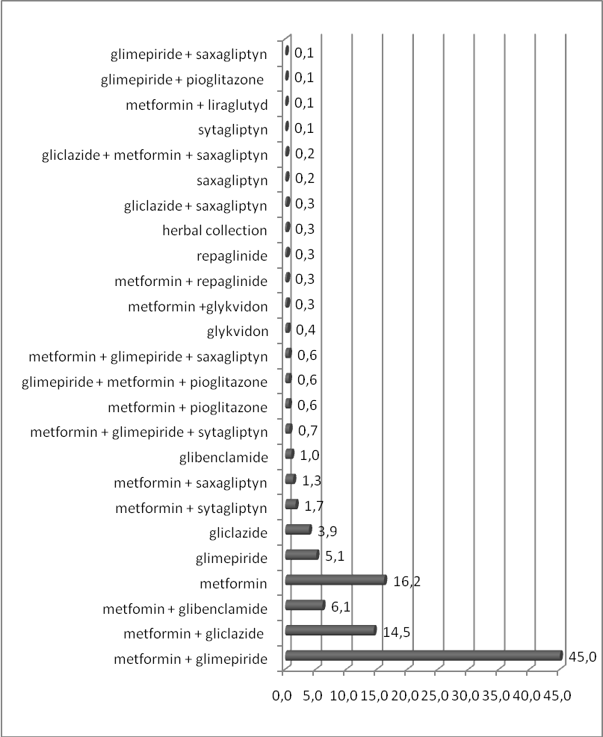
Figure 1. Frequency analysis of the treatment regimens of T2DM patients in the Podolsky region 2011 – 2013.

So, in the pharmacoeconomic research there were included three most commonly used combination drug regimens of T2DM: metformin + glimepiride, metformin + gliclazide and metformin + glimepiride.
When comparing the indicators of groups of patients which were prescribed combined therapy found that patients with metformin + glibenclamide were significantly older, with the largest disease duration of T2DM, with the highest BMI and lowest levels of FPG on admission.
When comparing the indicators of groups of patients who received combined therapy of metformin + glimepiride and metformin + gliclazide found significantly longer duration of disease in patients with the scheme metformin + gliclazide and more FPG on admission in patients with scheme metformin + glimepiride, in other analyzed indicators do not found significant differences (Table 1).
Table 1.
Characteristics of patients at different combined regimens of pharmacotherapy
№ | Indicators | Pharmacotherapy schemes |  |  | The significance of differences
№ | Indicators | metformin + glimepiride | metformin + gliclazide | metformin + glibenclamide | The significance of differences
1. | The number of patients | 807 | 259 | 110
2. | Age , years | 56.86±0.62 | 57.68±1.16 | 59.33±1.81 | р_{1–2} > 0,05  р_{1–3} < 0,05  р _{2– 3} > 0,05
3. | Duration of illness, years | 6.87±0,34 | 7.81±0.75 | 9.43±1.35 | р_{1–2} < 0,05  р_{1–3} < 0,05  р _{2– 3} < 0,05
4. | BMI , kg/m2 | 32.97±0,47 | 31.07±0,65 | 32.03±1.18 | р_{1–2} < 0,05  р_{1–3} > 0,05  р _{2– 3} > 0,05
5. | FPG on admission, mmol/L | 10.71±0.19 | 10.32±0.34 | 11.11±0.57 | р_{1–2} < 0,05  р_{1–3} > 0,05  р _{2– 3} < 0,05
6. | Hospital stay , days | 10.90±0.13 | 10.82±0.22 | 10.90±0.39 | р_{1–2} > 0,05  р_{1–3} > 0,05  р _{2– 3} > 0,05

DDD (defined daily dose, average daily dose) was studied for ATC/DDD-analysis for oral hypoglycemic drugs with the International Nonproprietary Name (INN) metformin: 2000 mg, 60 mg for gliclazide, 2 mg for glimepiride, 10 mg for glibenclamide [5]. Тheir prices were researched in UAH at the regional pharmaceutical market of Podolsky region with calculation value of each pharmacotherapy regimens in the context of price of generics.
ATC/DDD-analysis showed that the cost for DDD of combination metformin + glimepiride ranges is from 2.70 (Dianormet 850 mg t. № 30 + Diapiryd 3 mg t. № 30) to 8.88 UAH (Siofor 500 mg t .№ 60 + Amaril 2 mg t. № 30 – 207 versions of generic combinations were applied), metformin + gliclazide – from 3.29 (Diaformin 850 mg t. № 60 + Diaglizyd MR 30 mg t. № 60) tо 9.43 UAH (Siofor 500 mg t.№ 60 + Diabeton MR 60 mg t. № 30 – 70 versions of generic combinations were applied), metformin + glibenclamide – from 1.98 (Diaformin 850 mg t. № 60 + Glibenclamide 5 mg t. № 100) tо 6.20 UAH (Siofor 500mg t. № 60+ Maninil 3.5 mg t. № 120 – 72 versions of generic combinations were applied).
Cost-effectiveness analysis was conducted for pharmacoeconomically justification of a therapy of the combinated treatment regimens of T2DM.
The unit of effectiveness was adopted as a percent of effective patients. The effective patients are the patients whose FPG levels after pharmacotherapy reached ≤ 7mmol/L [1, 2]. Number of effective patients and efficiency in percent for each scheme were identified. Number of effective patients determined in the context of the analyzed regimens of T2DM.
It has been found that clinical efficacy of combination metformin + glimepiride is 50.3% (this scheme was used in 807 patients, number of patients whose FPG level after pharmacotherapy became ≤ 7mmol/L is 406 patients, this is 50.3%), scheme metformin + gliclazide has clinical efficacy of 59,1% (from 259 patients – 153 effective patients), scheme metformin + glibenclamide has clinical efficiency 49.1% (from 110 patients – 54 effective patients).
It has been calculate the costs-efficiency ratios (CER) in the context of minimal and maximal price of generics according to the formula [4]:
CER = DC/Ef, where
DC – direct cost of pharmacotherapy
Ef – individual indicator of efficiency
Cost-effectiveness analysis showed that the cost of CER for metformin + glibenclamide ranges from 40.33 to 126.27 UAH, metformin + glimepiride – from 53.68 to 176.51 UAH, metformin + gliclazide – from 55.69 to 159.63 UAH, in the context of minimal and maximal price of generics (Table 2).
Obtained results indicate the cost-effective advantages of the scheme of combined therapy metformin + glibenclamide.
Sensitivity analysis was conducted to determine the stability of the cost-effectiveness analysis results. One-way sensitivity analysis showed that the scheme of metformin + glibenclamide keeps pharmacoeconomic advantages to increased cost of DDD up to 33% in comparison with scheme metformin + gliclazide and to 29% in comparison with scheme metformin + glimepirid, further increase the cost of DDD leads to a loss of pharmacoeconomic advantages. Two-way sensitivity analysis showed that the scheme of metformin + glibenclamide keeps pharmacoeconomic advantages to increased cost of DDD up to 17% in comparison with scheme metformin + gliclazide and to 159% in comparison with scheme metformin + glimepirid, further increase the cost of DDD and decrease efficiency leads to a loss of pharmacoeconomic advantages.

Table 2.

The results of the cost-effectiveness analysis for combined drug regimens

Scheme of pharmacotherapy,  INN | Scheme of pharmacotherapy,  trade names | Cost of DDD,  UAH | Cost of DDD10 days,  UAH | Number of effective patients, % | Costs-efficiency ratioCER=  DC/Ef, UAH
metformin + glibenclamide | Diaformin 850 mg t. № 60 + Glibenclamide 5 mg t. № 100 | 1.98 | 19.80 | 49.1 | 40.33
metformin + glibenclamide | Siofor 500mg t. № 60+ Maninil 3.5 mg t. № 120 | 6.20 | 62.00 | 49.1 | 126.27
metformin + gliclazide | Diaformin 850 mg t. № 60 + Diaglizyd MR 30 mg t. № 60 | 3.29 | 32.90 | 59.1 | 55.69
metformin + gliclazide | Siofor 500 mg t.№ 60 + Diabeton MR 60 mg t. № 30 | 9.43 | 94.30 | 59.1 | 159.63
metformin + glimepiride | Dianormet 850 mg t. № 30 + Diapiryd 3 mg t. № 30 | 2.70 | 27.00 | 50.3 | 53.68
metformin + glimepiride | Siofor 500 mg t .№ 60 + Amaril 2 mg t. № 30 | 8.88 | 88.80 | 50.3 | 176.51

Questionnaire EuroQol - 5D (adapted European questionary of quality of life) was used for the cost-utility analysis (Ukrainian Version for Ukraine). The quality of life of patients was determined by visual analogue scale (VAS) This method is based on a subjective assessment of the patient’s status from the worst (0%) to the best (100%) state [3]. To facilitate the calculation the percent that was noted by patients on the VAS (from 0% to 100% with step 1%), was transferred to the unit (from 0 to 1 with step 0.1). 50 patients who used studied treatment regimens were included in the cost-utility analysis.
The following formula was used to calculate the number of quality life years (QALYs):
С = D х F, where
C - number of quality life years
D - years of future life
F - quality of life (according to VAS)
It has been found the quality of life was 0.58±0.02 for patients with treatment regimen metformin + glibenclamide, 0.69±0.02 – for patients with metformin + glimepiride and 0.65±0.02 – for patients with metformin + gliclazide.
The average life expectancy of the patients with T2DM is 71 according to the WHO, 2012 [6]. In this research it was found that the average age of the patients who used metformin + glimepiride was 56.86 ± 0.62 and future years of life for this patients will be 14.14 ± 1.11; metformin + gliclazide – 13.32 ± 0.97, respectively; metformin + glibenclamide – 11.67 ± 1.09, respectively. The number of QALYs for the patients who used the scheme of pharmacotherapy with metformin + glibenclamide was 6.77±0.66, metformin + glimepiride – 9.76±0.74 QALYs, and metformin + gliclazide – 8.66±0.64 QALYs.
The costs of pharmacotherapy taking into account duration of patient’s life and cost in DDD by minimal price of generics will amount for metformin + glibenclamide 8434.80 UAH, metformin + glimepiride – 13934.70 UAH and metformin+gliclazide – 15877.54 UAH.
The costs of pharmacotherapy taking into account duration of patient’s life and cost in DDD by maximal price of generics will amount for metformin + glibenclamide 26412 UAH, metformin + glimepiride – 45829.68 UAH and metformin + gliclazide – 45848.66 UAH.
The costs-utility ratio (CUR) was calculated according to the formula [4]:
CUR = DC / Ut, where
CUR – the cost / utility
DC – direct costs of pharmacotherapy
Ut – utility of treatment regimens
It has been found that the scheme metformin + glibenclamide had the cheapest cost of unit utility for combined therapy: 1245.91 – 3901,33 UAH in comparison with metformin + glimepiride that had the cost of unit utility – 1427,74 – 4695.66 UAH and metformin + gliclazide – 1847.11 – 5294.30 UAH (Table 3).

Table 3.

The results of the cost-utility analysis for combined drug regimens

Scheme of pharmacotherapy,  INN | Scheme of pharmacotherapy,  trade names | Cost of DDD,  UAH | Cost of DDD10 days,  UAH | Number of QALY | Costs- utility  CUR = DC / Ut, UAH
metformin + glibenclamide | Diaformin 850 mg t. № 60 + Glibenclamide 5 mg t. № 100 | 1.98 | 8434.80 | 6.77±0.6 | 1245.91
metformin + glibenclamide | Siofor 500mg t. № 60+ Maninil 3.5 mg t. № 120 | 6.20 | 26412 | 6.77±0.6 | 3901.33
metformin + gliclazide | Diaformin 850 mg t. № 60 + Diaglizyd MR 30 mg t. № 60 | 3.29 | 15877.54 | 8.66±0.64 | 1847.11
metformin + gliclazide | Siofor 500 mg t.№ 60 + Diabeton MR 60 mg t. № 30 | 9.43 | 45848.66 | 8.66±0.64 | 5294.30
metformin + glimepiride | Dianormet 850 mg t. № 30 + Diapiryd 3 mg t. № 30 | 2.70 | 13934.70 | 9.76±0.74 | 1427.74
metformin + glimepiride | Siofor 500 mg t .№ 60 + Amaril 2 mg t. № 30 | 8.88 | 45829.68 | 9.76±0.74 | 4695.66

Obtained results indicate the cost-utility advantages of the scheme of combined therapy metformin + glibenclamide.
One-way sensitivity analysis showed that the scheme metformin + glibenclamide keeps pharmacoeconomic advantages to increased cost of DDD up to 40% in comparison with scheme metformin + glimepirid and to 14% in comparison with scheme metformin + gliclazide, further increase the cost of DDD leads to a loss of pharmacoeconomic advantages. Two-way sensitivity analysis showed that the scheme metformin + glibenclamide keeps pharmacoeconomic advantages to increased cost of DDD up to 19% in comparison with scheme metformin + glimepirid and to 6% in comparison with scheme metformin + gliclazide, further increase the cost of DDD and decrease efficiency leads to a loss of pharmacoeconomic advantages.
On the base of results of the pharmacoeconomical investigation we created a model of "Decision Tree" which is an instrument to decide on the selection of pharmacoeconomic justified therapy [3]. The research results were illustrated graphically in this model. The branches of the “Decision Tree” describe the alternate treatment regimens in the context of cost of effectiveness unit and cost of utility unit (Figure. 2).
This scheme shown that the cost-effectiveness and cost-utility advantages of combined therapy metformin + glibenclamide, in the context of the minimal and maximal price of generics, despite the fact that patients who were treated with this scheme were significantly older and had a significantly longer duration of type 2 diabetes mellitus.

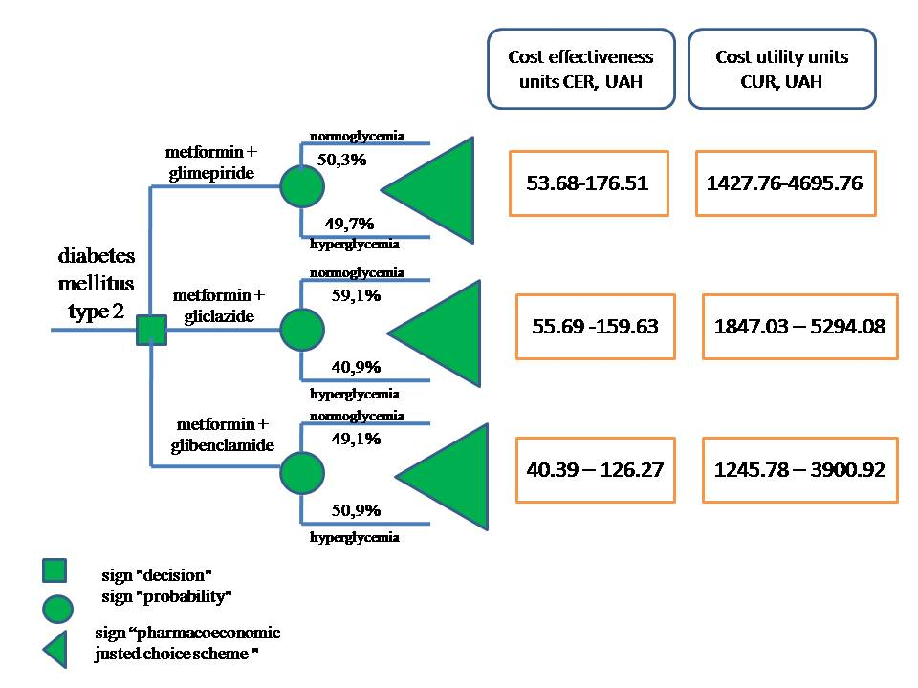
Figure. 2. Model "decision tree" pharmacotherapy of patients with T2DM using 3 combined schemes
Conclusions:
1) The frequency analysis showed that the most frequently used schemes of pharmacotherapy were: metformin + glimepiride – in 45% of cases, metformin + gliclazide – in 14,5 % of cases, metformin + glibenclamide – in 6,1%.
2) Scheme of combined therapy metformin + glibenclamide has cost-effective and cost-utility advantages in comparison with other shemes, and the sensitivity analysis showed the stability of the pharmacoeconomic study results.
3) The mathematical model "Decision Tree" graphically shows the results of the pharmacoeconomic investigation.

References:
- Boychuk Т. М. Glycated proteins in diabetes: the phenomenon of formation and pathogenetic effects (review) / Boychuk T.M., Tolstanov D.C., Grytsiuk M.I., Gozhenko A.I. // Actual problems of transport medicine: the environment; occupational health; pathology. – 2013. – № 3. – С. 52-59
- Unified clinical protocols of primary and secondary (specialized) medical care [electronic resource]: order of the MoH Ukraine of 12.21.2012 p. № 1118 - Access: https://www.moz.gov.ua/docfiles/dod1118_2_2012.pdf
- Kulikov A.Y. The methodology of modeling in pharmacoeconomics / A.Y. Kulikov, T.T. Nguyen, Tikhomirov A. // Pharmacoeconomics. – 2011. – № 4, – С.8-16
- Yagudina R.I. Pharmacoeconomics of diabetes 2 type. R.I.Yagudin, A.Y. Kulikov, E.E.Arinina // Medical News Agency, 2011. – с. – 4 – 66
- ATC/DDD Index 2014. – [Eлектронний ресурс]. – Режим доступу: http://www.whocc.no
- Life expectancy 2012 – [Eлектронний ресурс]. – Режим доступу: www.who.int/gho/mortality.../life_tables/.../en

